

PDC GUI Programming Documentation
Internal Document

Document

Project name | Internal Development – PDC GUI
Author | Michal Marusan
File name | 0000.doc
Version | 1.0
Status | Final

Document Properties

Change Control

Attribute | Value
Written by | Michal Marusan
Reviewed by | Marek Velešík

Revision History

Date | Number | Description
2011-01-01 | 0.1 | Working
2011-12-06 | 1.0 | Final

Distribution List

Name | Contact Details | Abbr.

Content

1 Request 1
2 Definitions, Acronyms and Abbreviations 2
3 Solution Design 3
3.1 Design techniques 3
3.1.1 ASPX Page layout 3
3.1.2 Session object 4
3.1.3 Panel showing/hiding 4
3.1.4 Parameter GET passing 7
3.1.5 Use of Grids (GridView and DataSource) 7
3.1.6 Monitor Header 8
3.1.7 Configuration file 9
3.1.8 Security 10
3.1.9 Menu 14
3.1.10 Info Panel – Displaying info 17
3.1.11 Database Connection 18
3.1.12 Main Filter 19
3.1.13 Status bar 22
3.2 Monitor 23
3.2.1 Monitor – default screen 24
3.2.2 Stream View 24
3.2.3 Job View 26
3.2.4 Running Jobs 28
3.2.5 Failed Jobs 30
3.2.6 Ready to Run Jobs 31
3.2.7 Finished Jobs 32
3.2.8 All Jobs 33
3.2.9 Odd Jobs 34
3.3 Control 36
3.3.1 Scheduler 36
3.3.2 Finish Jobs 38
3.3.3 Restart Jobs 40
3.3.4 Restart Finished Jobs 41
3.3.5 Block 42
3.3.6 Unblock Jobs 43
3.3.7 Manual Batch 44
3.4 Logs 49
3.5 Session Tables 50
3.6 CTRL Tables 51
3.6.1 Stream 52
3.6.2 Job 53
3.6.3 Stream Dependency 54
3.6.4 Job Dependency 56
3.6.5 Stream Plan Ref 58
3.6.6 Job Table Ref 59
3.7 Admin 60
3.7.1 Label Maintenance 60
3.7.2 Change Management 61
3.7.3 Access Control 62
3.7.4 User Management 63
3.8 Reports 63
3.9 Change Password 63
4 Installation 63
4.1 Prerequisites 63
4.1.1 Hardware components 63
4.1.2 Software components 63
4.2 Installation steps 63
4.3 Troubleshooting 69
4.3.1 Version of OS vs ODBC 69
5 Future requests 71

Request
Create GUI for PDC application. GUI will be implemented in ASPx .NET to be able to run on Microsoft IIS.

PDC GUI Description
Metadata permits PDC application administers all parts of its functionality. GUI application is WEB based application supporting standard browser functionality and using Teradata Viewpoint graphical layout. The user must have appropriate permissions for working with any part of the application. The main ask on GUI application is to enable comfortable monitoring and controlling of job processing, but GUI application is not necessary for PDC work. Jobs can be located in different instances of PDC; these instances are totally independent and are used for controlling and monitoring independent data processing. GUI shows only jobs located in selected instance of PDC but on status line are displayed statuses of all instances simultaneously. For selecting only specific part of objects a filter can be used on stream and job level. GUI consists from several parts whose meaning and functionality is described below.

Status line
Status line is located in the top level of GUI application and shows the number of the engine which is selected for monitoring and controlling. Statuses of other Engines and Schedulers are also displayed. For faster touching of information which is looked for a filter can be used.

Monitor
Monitor is used for displaying of current status of processing. The information can be presented from stream or job point of view. Drill down functionality enables drill for further details, so from stream view the user can drill down the information of how many jobs are located in the stream, what they are and what their status is. User can also drill down to parameters of selected job. On job level the user operates the job; it means he can abort running job, restart or finishing failed job and so on. Jobs and streams are divided into processing classes which represents objects state such as prepare for run, running, finished, failed and so on. The environment, load date and task type is shown as well as display refresh rate and maximal number of concurrently running jobs. The status overview part contains number of currently running jobs, number of failed jobs, number of jobs prepared for run and number of already finished jobs shows. All these numbers support drill down functionality, it means you can directly get a list of jobs in a category by clicking on the appropriate number.

Control
Control enables access to all necessary settings used for controlling of PDC application. Same basic functionality for job processing is also located on the monitor part, but Control part enables driving parallelisms, temporary stop the Scheduler or doing control task on job level simultaneously for group of jobs. User can also simply stop executing jobs on selected dependency branch by blocking its parent job. Manual Batch functionality enables recalculation of selected jobs for chosen load date. It’s often used for datamarts recalculation for the day.

Logs
Logs display controlling steps done on PDC application – it enables potential supervisor cooperation on problem solving, and also all problems captured by Framework checker application.

SESS TABLES
SESS (session) tables contain operational metadata and store actual status of objects. SESS TABLES part enables changes in the table content. Such change can represent increasing actual job priority, command line changes and so on.

CTRL TABLES
CTRL (control) tables store configuration metadata of jobs, streams, their dependences, locks and calendars. This part of GUI application is used for creating or changing this metadata. Application automatically checks correctness of typed values. Changes are enabled only when a label is selected which is necessary for change management process package creation.

Admin
Admin section contains necessary administrative tasks such as label maintenance, change management process, access control and so on.

Reports
Reports page is a signpost for customer reports related for PDC processing. Customers can simply use their reporting tools for creating reports based on PDC metadata and place them on this page.

Definitions, Acronyms and Abbreviations
This chapter contains basic terminology used within this document and across the project PDC GUI.

Definitions, Acronyms and Abbreviations
PDC | Process Dispatch Center – name of the scheduler application
ASPx .NET | Programming Language and platform

Solution Design
This chapter describes the solution in detail divided into several sections according to the page layout of the GUI and one (first) section describing general techniques used throughout the whole project.

Design techniques
This chapter describes general design techniques used throughout whole PDC GUI project. These techniques are described in the following chapters.

ASPX Page layout
This section describes basic layout of the ASP pages. The PDC GUI is based on the Master – Content page layout. Master page contains maximum of information and controls that are used throughout the GUI pages – e.g. Menu (see 3.1.9 Menu), Status Bar (see 3.1.13 Status bar) or Main Filter (see 3.1.12 Main Filter). The Content page is different for each page (section).
The following image shows Master page contents (in red area).

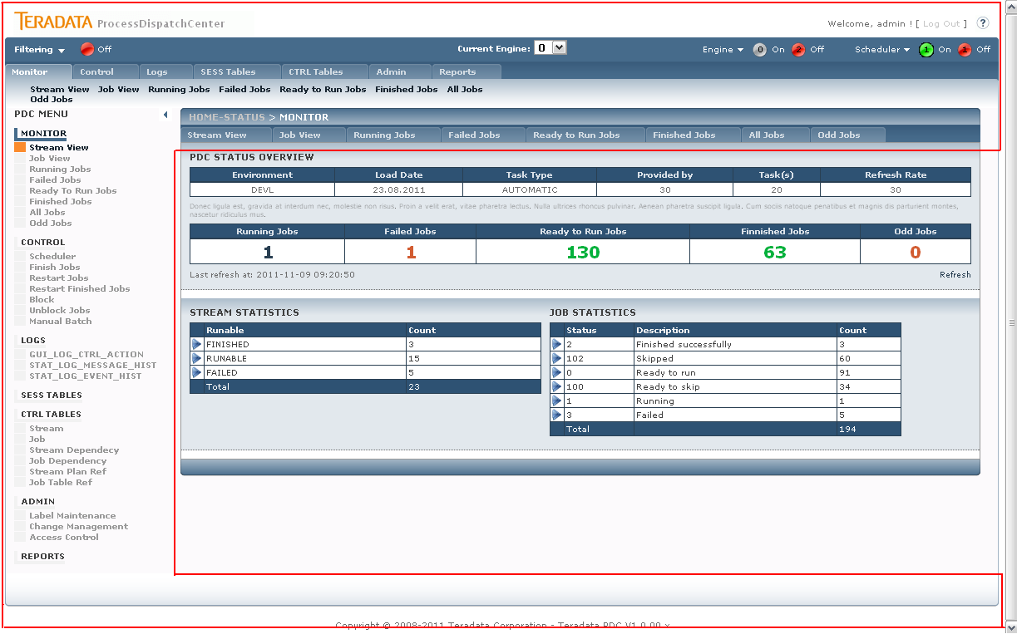
Figure 1 Master-Content page division

Calling Master page methods
Some methods that are mostly used throughout the PDC GUI project are defined onlz in the Master page and the called from Content page if needed. The syntax is:

((SiteMaster)Master).masterMethodName(parameters);

Sometimes is needed to call a Master page method from Custom Control – the syntax is little different:

((SiteMaster)(this.Page).Master).masterMethodName (parameters);

Session object
The Session objects are used in the PDC GUI to maintain information between page reloads (changing section, post-backs …). There are three main types of information the Session object is used for throughout the front end:
- Handling the Main Filter (filtering of jobs, streams)
- Panel showing/hiding (see next chapter)
- Storing important values (engine no., label)

Complete list of used sessions:
Session Name | Usage / Purpose
LeftMenuVisible | Handles showing/hiding of panel containing left menu
PanelFilterEnabled | Handles showing/hiding of panel containing filter definition.
PDCEngineSelected | Stores selected engine number.
PDCShownPanelsList | Handles showing/hiding of panels. Contains panel names to show.
TChangeManagementLabel | Stores selected LABEL_NAME.
MainFilterEnabled | True if Main Filter is enabled, the filtering is on.
TFilterJobCategory | Stores particular filter value which is passed to the procedures.
TFilterJobName | Stores particular filter value which is passed to the procedures.
TFilterJobType | Stores particular filter value which is passed to the procedures.
TFilterPhase | Stores particular filter value which is passed to the procedures.
TFilterStreamName | Stores particular filter value which is passed to the procedures.
TFilterTableName | Stores particular filter value which is passed to the procedures.

Panel showing/hiding
The page is implemented as step-by-step reveling of detailed sub-sections depending on the user selection. The page goes from overview mode (single grid view) to the full detail mode (all sub-section grids):
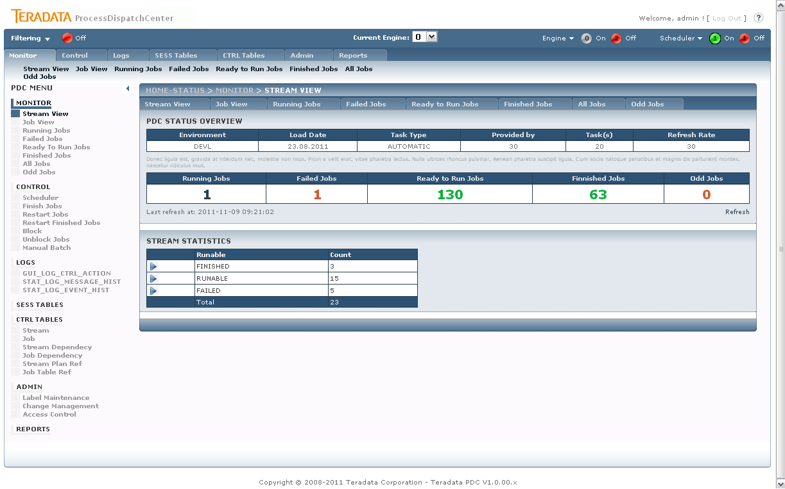
Figure 2 PDC Monitor – Stream view – overview mode

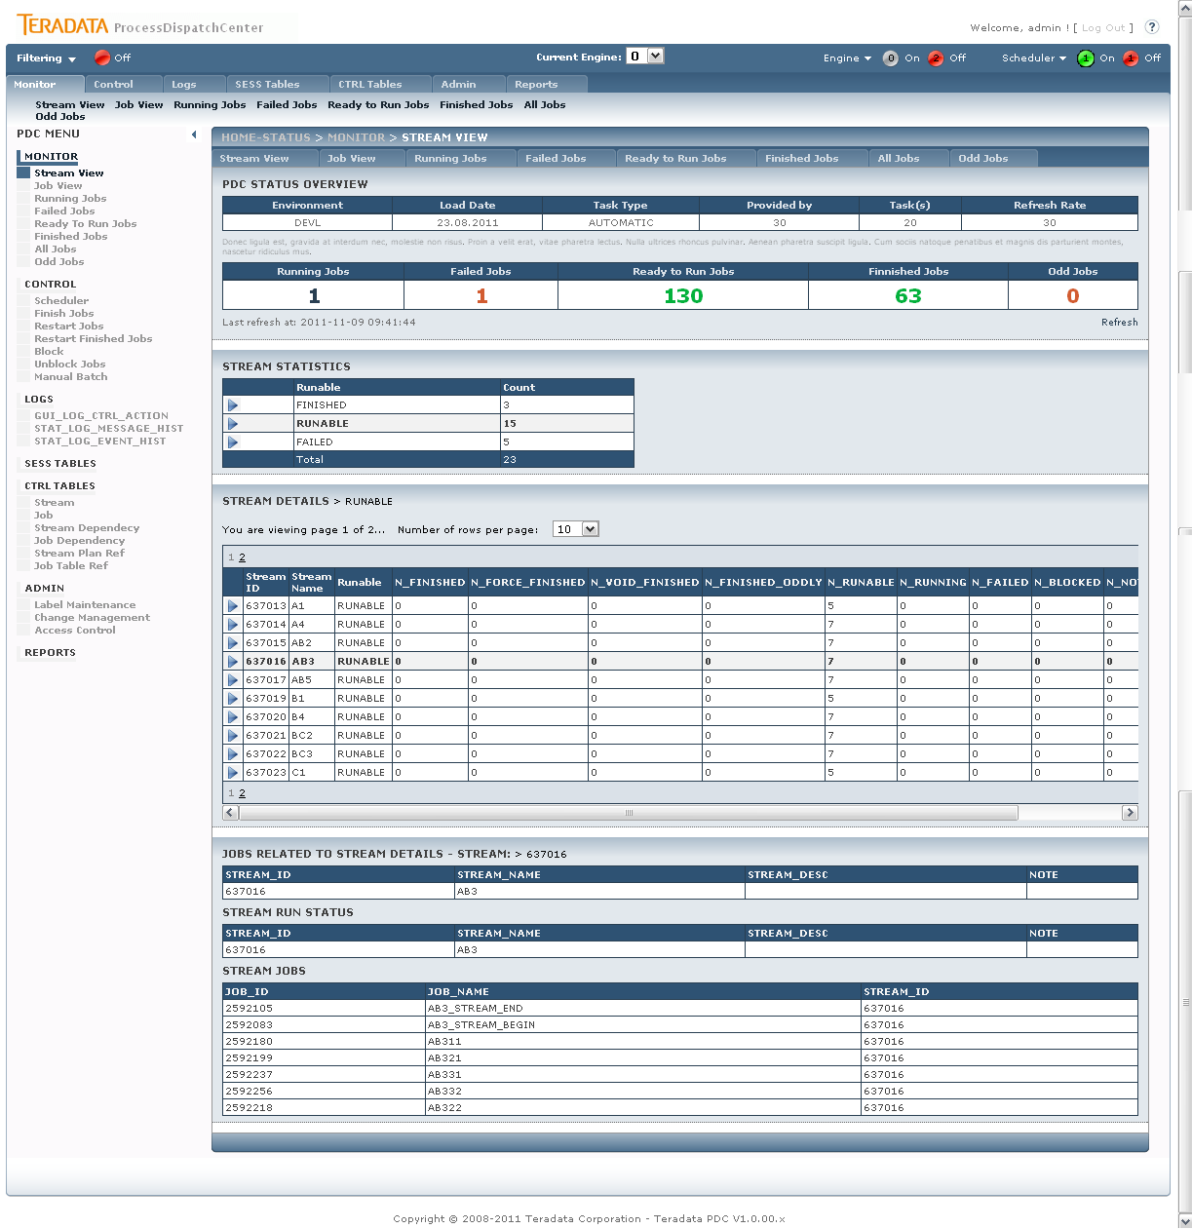
Figure 3 PDC Monitor – Stream view – full detail mode

The implementation is as follows: the UI of the page is divided into several sections according to the different level of detail. These sections are included into the ASPX Panel object (which is renderd as DIV HTML element) where the panel visibility is driven by the user interaction.
Panels:
- p_Master – overview grid
- p_Detail_lvl1 – list of streams/jobs
- p_Detail_lvl2 – details panel
The panel current visibility settings is stored in Session objects between post backs - Session["PDCShownPanelsList"]. In the Page Load event of the section is called the Master page function which handles the panel visibility - handleRevealingOfPanels(). The function is implemented in the Master and thus can be referenced by several Content pages. Sample of calling is illustrated in the box bellow:

protected void Page_Load(object sender, EventArgs e)
{

//code omitted for brevity

((SiteMaster)Master).handleRevealingOfPanels();

}

Parameter GET passing
Passing parameters via GET is used in one case through the all GUI – when selecting a specific row in the default Monitor page (see chapter 3.2.1 Monitor – default screen). The parameter is Stream or Job selected status and the user is redirected to the specific page Stream View or Job View, respectively.
In the destination page, the parameter is processed in the PageLoad event, illustrated in the following code:
protected void Page_Load(object sender, EventArgs e)
{
// code omitted for brevity

if (!IsPostBack)
{

//handle if filter is passed from another page -> from Monitor page to detail...
if (Request.QueryString["filter"] != null)
{
int i = 0;
//go through gridview (master)
foreach (GridViewRow gr in gv_Master.Rows)
{
if (gr.Cells[1].Text == Request.QueryString["filter"])
{
gv_Master.SelectRow(i);
return;
}
i++;
}

gv_Master_SelectedIndexChanged(gv_Master, null);
}
}
else
{
...
}

}

Use of Grids (GridView and DataSource)
The PDC GUI solution hugely benefits from using the native ASPX data objects - GridView. GridViews objects used in PDC GUI are set declaratively – data sources are set declaratively and basic properties are set declaratively. The schema is as follows:
- Create Gridview
- Define ID and basic parameters
- Define DataSourceID (declaratively)
- Create DataSource for the GridView
- Specify parameters
- Specify GridView columns (not auto-generated)

<asp:GridView ID="gv_Detail_lvl1" runat="server"
DataKeyNames="JOB_ID"
DataSourceID="SqlDataSource_gv_Detail_lvl1"
AllowSorting="True"
AutoGenerateColumns="False"
CellPadding="2" CellSpacing="1"
GridLines="None"
CssClass="PDCTbl"
EmptyDataText="No rows"
EnableViewState="False"

AllowPaging="True"
PageSize="<%$ AppSettings:DefaultPageItemCount %>"
PagerSettings-Position="TopAndBottom"
PagerSettings-Mode="NumericFirstLast"

ondatabound="gv_Detail_lvl1_DataBound"
OnSelectedIndexChanged="gv_Detail_lvl1_SelectedIndexChanged"

>
<Columns>
...
</Columns>
<RowStyle CssClass="PDCTblRow" Wrap="False" />
<SelectedRowStyle CssClass="PDCTblSelRow" />
<SortedAscendingHeaderStyle CssClass="sort_asc" />
<SortedDescendingHeaderStyle CssClass="sort_desc" />
<AlternatingRowStyle CssClass="PDCTblEvenRow" />
<HeaderStyle CssClass="PDCTblHeader" />

<PagerStyle CssClass="PDCTblPaging" />
</asp:GridView>

Most of the GridViews used in PDC GUI have implemented paging mechanism with drop down list defining number of items per page.

Monitor Header
The Monitor Header is a PDC Status Overview panel area containing basic information of current PDC engine. The panel is implemented as custom ASPX User Control (PDCMonitorHeader.ascx). This custom control is then included into each Content Page of all PDC Monitor sections.
The Monitor Header panel is implemented as AJAX Update panel in order to allow a separate refresh period (independent from the rest of PDC GUI). The reload period is driven by the PDC parameter (set in DB) when the current reload time is displayed in the lower left corner of the panel (see in picture bellow).
The panel the other depicted area (lower right) is a refresh button which causes the additional user-requested refresh of the Monitor Header panel. The refresh is implemented as simple reload.
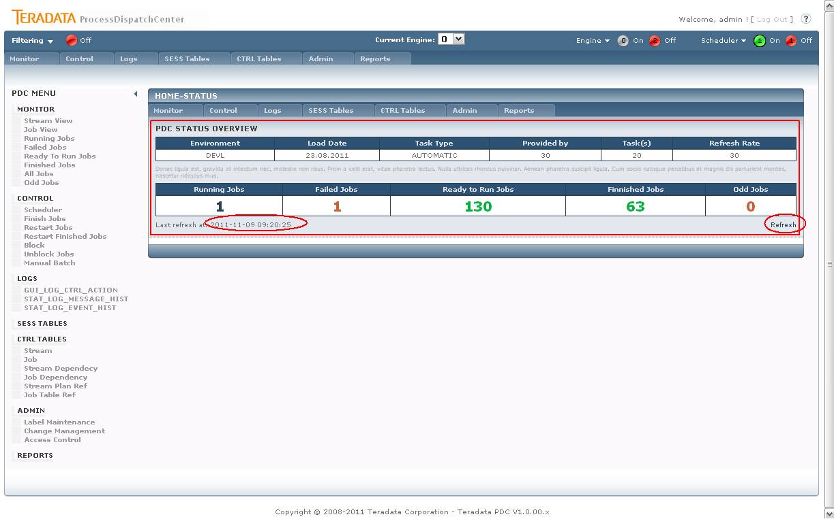
Figure 4 PDC Monitor Header

Procedure: PCKG_GUI.SP_GUI_VIEW_HEADER_MAIN

The procedure returns output parameters only (no record set) which are then displayed in the simple HTML table.
The numbers of Jobs (second table row – Running, Failed,…) are implemented as link to its detailed pages, i.e. number of Running Jobs is link to section Running Jobs (these sections are described later).

Configuration file
The PDC GUI web application uses global ASP .NET configuration file – Web.Config. This file configures the application via XML variables – some are ASP .NET default other are user defined (per project).

Custom configuration properties
Session Name | Usage / Purpose
DefaultPageItemCount | Default count of displayed item per page in paged GridView
DefaultPageReloadTimer | Default page reload timer – if not specified in DB (Control Param)
DefaultEngine | Default Engine number – if not specified in DB (Control Param)
DisplayDebugSection | Handles displaying debug section (if true)
DefaultOracleDateFormat | Default date format to pass to Oracle DB

<?xml version="1.0"?>

<!--
For more information on how to configure your ASP.NET application, please visit
http://go.microsoft.com/fwlink/?LinkId=169433
-->

<configuration>

<connectionStrings>
...
</connectionStrings>
...
<appSettings>

<add key="DefaultPageItemCount" value="10" />
<add key="DefaultPageReloadTimer" value="20000" />
<add key="DefaultEngine" value="0" />
<add key="DisplayDebugSection" value="true"/>
<add key="DefaultOracleDateFormat" value="dd.MM.yyyy"/>
</appSettings>
...
</configuration>

Access to the property in code:

String var = (String)(ConfigurationManager.AppSettings["DefaultOracleDateFormat"]);

Authentication/Authorization properties
See chapter 3.1.8 Security

Database Connection
See chapter 3.1.11 Database Connection

Security
User security model is based on application roles. Simply, user is given role and then, the role is given the particular rights.
The mapping user to role is four-tier to allow the flexibility for future implementation of different authenticating methods (LDAP, …).
The User is mapped to User group (can represent the LDAP group), the User Group is mapped to the Application role and the role is given the effective rights. The overall simplified mapping is shown on the figure bellow.
GUI_AUTH
GUI_ACCESS_USER_GROUP_REF
GUI_ACCESS_GROUP_ROLE_REF
GUI_ACCESS_ROLE_RIGHT_REF
User1
Group 1
Role 1
Right A
Right B
…
Figure 5 PDC User to Role mapping

The PDC Group to Role mapping is implemented as 1:1 relation, but in general the relation can be N:1.

User Authentication
User is authenticated via login and passport against the database. The credentials are stored in database table GUI_AUTH. The password is hashed via standard .NET method.

using System.Security.Cryptography;

...

MD5CryptoServiceProvider md5Hasher = new MD5CryptoServiceProvider();
Byte[] hashedBytes;
UTF8Encoding encoder = new UTF8Encoding();

//hash the password
hashedBytes = md5Hasher.ComputeHash(encoder.GetBytes(password));

Page Authorization
All ASPX pages are under authorization process by default, i.e. all pages are accessible only after login, except the login page and error page. These settings are stored in the Web.Config file of the ASPX NET project. The mentioned part of the configuration file is bellow.

<?xml version="1.0"?>

<!--
For more information on how to configure your ASP.NET application, please visit
http://go.microsoft.com/fwlink/?LinkId=169433
-->

<configuration>

...
<system.web>
...
</customErrors>

<authentication mode="Forms">
<forms loginUrl="~/Account/Login.aspx" timeout="2880" />
</authentication>

<authorization>
<deny users="?"/>
</authorization>

</system.web>

<location path="html">
<system.web>
<authorization>
<allow users="*"/>
</authorization>
</system.web>
</location>

<location path="errors">
<system.web>
<authorization>
<allow users="*"/>
</authorization>
</system.web>
</location>

...
</configuration>

User Management Support
Page: AdminUserMngmt.aspx
Procedures:
- PCKG_GUI.SP_GUI_UPDT_USER_MNGMT
- PCKG_GUI.SP_GUI_UPDT_USER_MNGMT_DEL
- PCKG_GUI.SP_GUI_VIEW_USER_MNGMT
The PDC GUI supports the user management by allowing the administrator to add, modify or remove users from system. Adding user is simple as add the user login and the User group. The user is created with the password same as login (user can change his password afterwards) – procedure: SP_GUI_UPDT_USER_MNGMT.
Administrator can change the existing User, he can change the User Group – modify the relation. This use the same procedure as user creation but the parameter defining the user password is left empty (NULL).

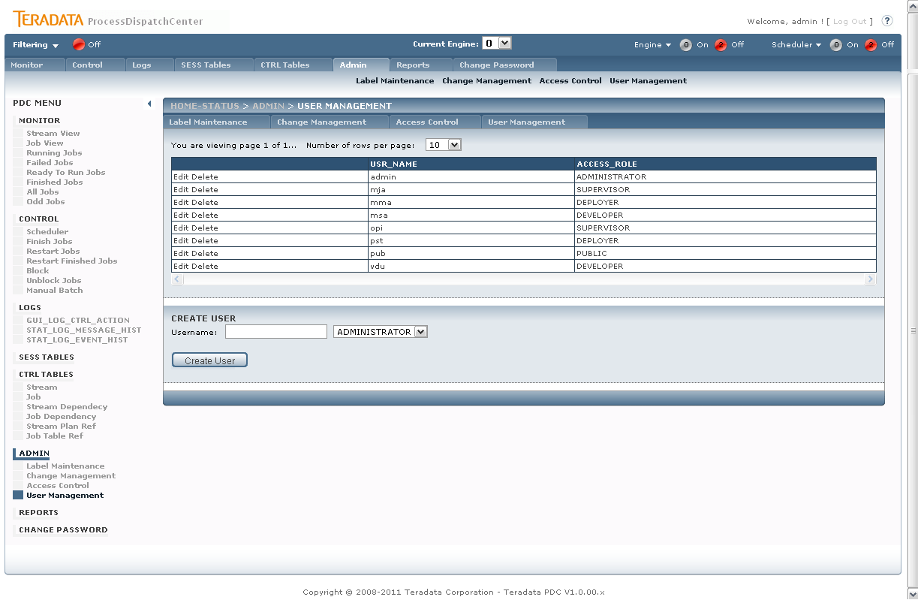
Figure 6 PDC User Management

Access Control
Page: AdminAccessControl.aspx
Procedures:
- PCKG_GUI.SP_GUI_VIEW_ACCESS_ROLE
- PCKG_GUI.SP_GUI_UPDT_ACCESS_ROLE
- PCKG_GUI.SP_GUI_UPDT_ACCESS_ROLE_DEL

The access control – user rights – is related to the application role. In order to implement the PDC security model complex, but flexible – the rights are related to the role and the GUI page the right are applied to. The right values are:
- Show – user can view/ has access to the page
- Control – user has access to the control section of the page (e.g. the action buttons on the Running Jobs detail page)

The administrator can change or modify the right assigned to the application role to control the access to the PDC GUI and functionality based on role.

Password Change
Page: AdminUserPasswdChng.aspx
Procedures:
- PCKG_GUI.SP_GUI_UPDT_USER_MNGMT_PASS
This page is visible to all users/roles by default. The page simply provides the user of password changing functionality based on the current logged user.
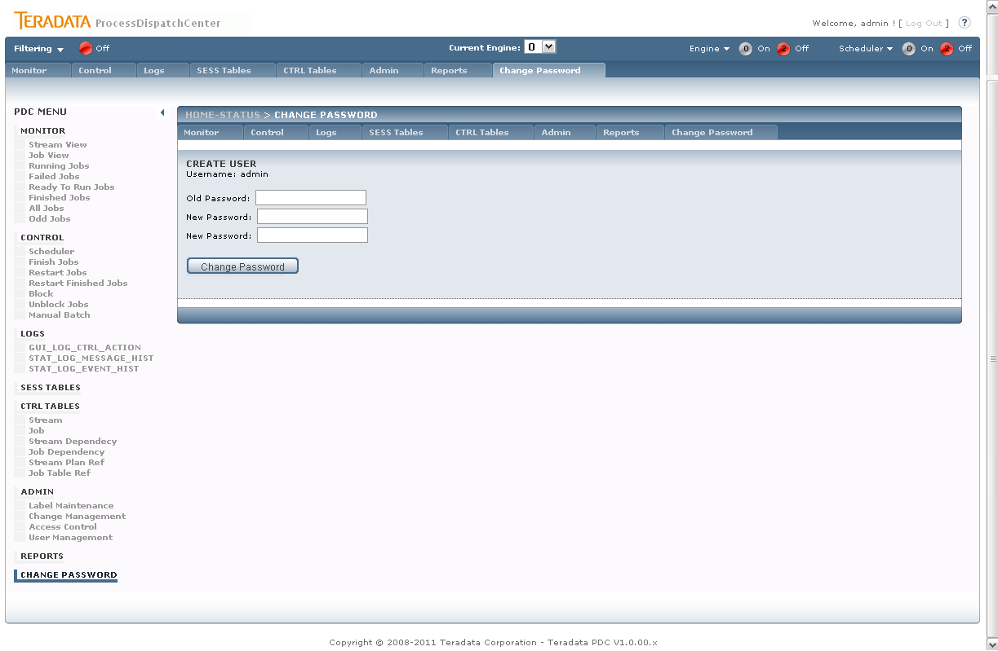
Figure 7 PDC User Management – Password Change

LDAP Support
Currently no LDAP support is implemented. But the table structure is designed to be flexible enough to implement support of almost any LDAP.

Menu
The PDC GUI application menu is implemented as ASPX .NET SiteMap object. The SiteMap supports a tree-structured menu and provides with basic objects for page navigation and the configuration is done by simple XML file editing.
The XML file looks like:

<?xml version="1.0" encoding="utf-8" ?>
<siteMap xmlns="http://schemas.microsoft.com/AspNet/SiteMap-File-1.0" >
<siteMapNode url="/Default.aspx" title="Home-Status" description="Home">
<siteMapNode url="/Monitor.aspx" title="Monitor" description="Monitor">
<siteMapNode url="/MonStream.aspx" title="Stream View" description="" />
...
</siteMapNode>
<siteMapNode url="/Control.aspx" title="Control" description="">
...
</siteMapNode>

</siteMapNode>
</siteMap>

The GUI navigation is divided into two main User Controls (see Figure 8 PDC Page Menu layout):
- Left Menu - PDCLeftMenu.ascx
- Top Menu - PDCTopMenu.ascx

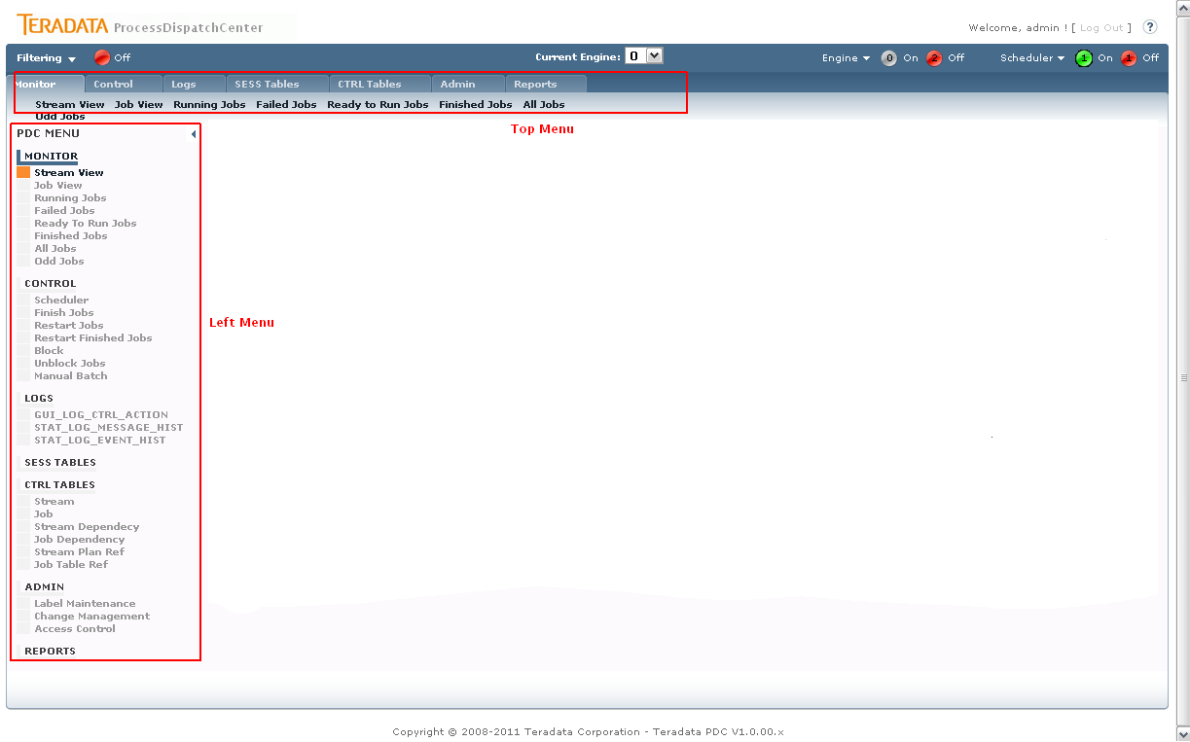
Figure 8 PDC Page Menu layout

Top Menu
Top provides user with navigation over the main section, where the current (selected) section sub menu is visible. The top menu is always visible.

Left Menu
Left menu list all section with all subsections and thus provide user with quick access to desired sub section. Moreover, the menu can be hidden and the page layout is stretched.
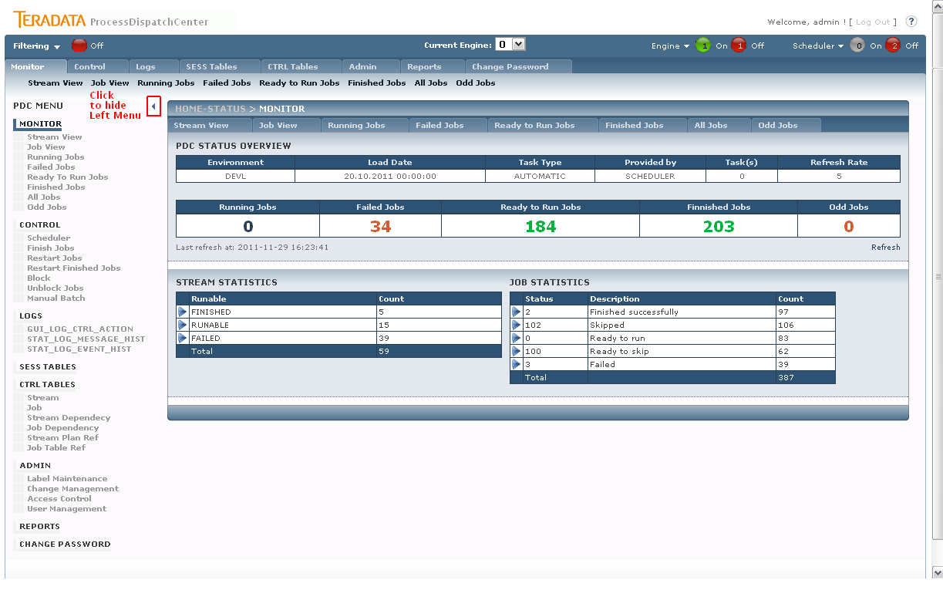
Figure 9 Left Menu – how to hide

The following picture shows the hidden left menu:
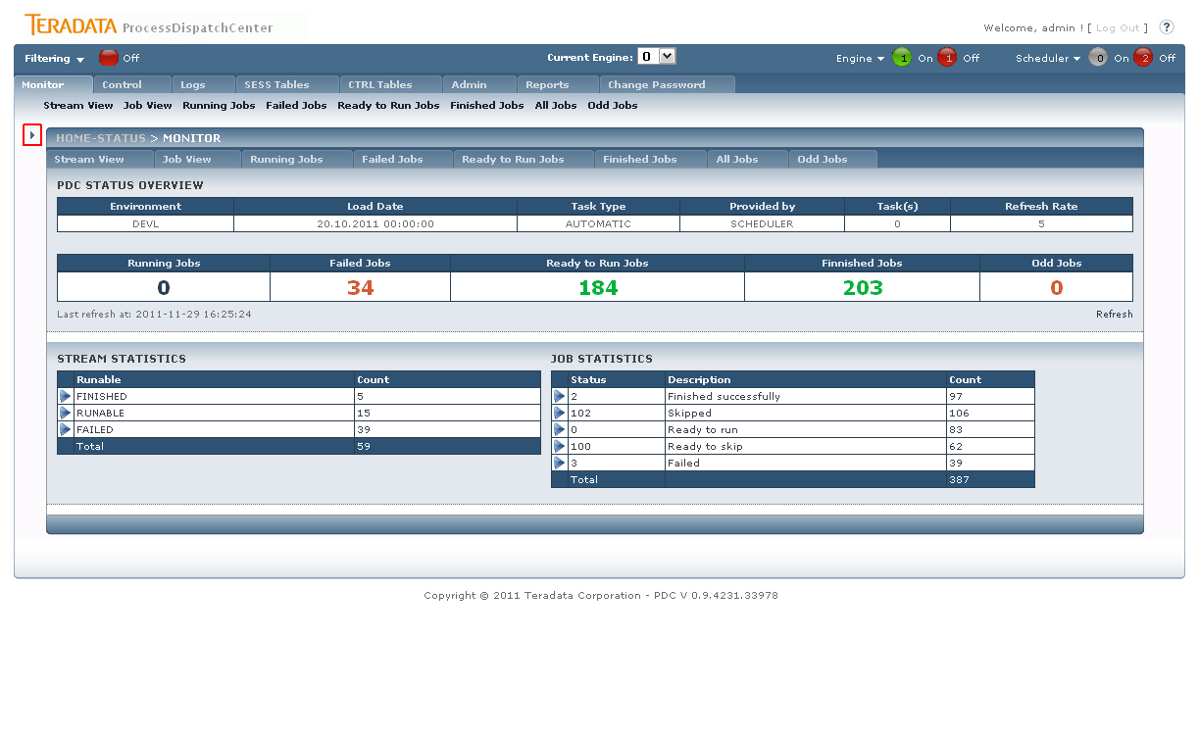
Figure 10 Left Menu – hidden menu

The left menu status (hidden or shown) is held in the Session (see 3.1.2 Session object).

Info Panel – Displaying info

PDC info panel (marked red on following picture) provides feedback to the user about action result or irregular state of current task. The default behavior is set to show only errors and inconsistent statuses.
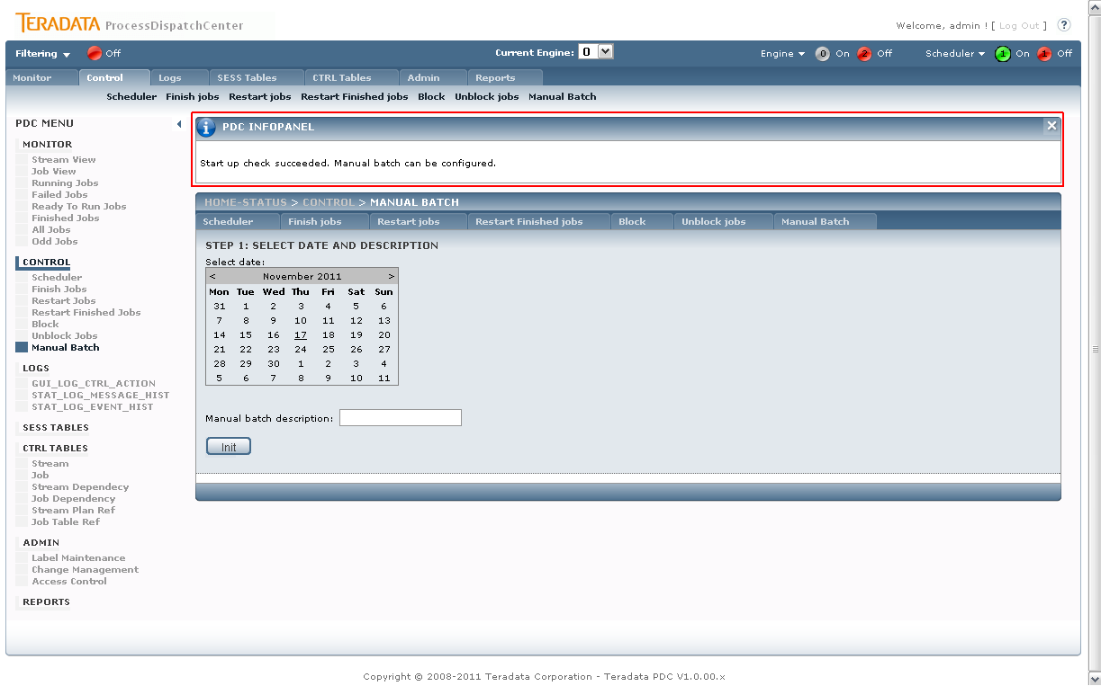
Figure 11 PDC Info panel (marked in red)

The implementation is based on the public method in Master Page – void displayInfo(string text). This method does not directly displays the message, it stores and adds the message in the message buffer (string variable) instead. The buffer is displayed on end of page process (event Page_LoadComplete) – this ensures that all messages are displayed.

Master methods:
/// <summary>
/// Display procedure execution status.
/// </summary>
/// <param name="p"></param>
public void displayInfo(string p)
{
this.procResultInfo += p;
}
/// <summary>
/// Handles displaying of message to the user.
/// </summary>
private void showFinalInfoInPanel()
{
if (this.procResultInfo.Length > 0)
{
pInfoPanel.Visible = true;
lInfo.Text = this.procResultInfo;
}
}

Master Load Complete call:
protected void Page_LoadComplete(object sender, EventArgs e)
{
...
//show info panel to the user (last call)
showFinalInfoInPanel();

}

Usage example (in Content Page):
((SiteMaster)Master).displayInfo("<br>" + "Sample message.");

Database Connection
Database connection is stored in the ASP .NET configuration file – Web.Config (see 3.1.7 Configuration file) The connection in ConnectionString property is used throughout the project.

Configuration file:
<?xml version="1.0"?>

<!--
For more information on how to configure your ASP.NET application, please visit
http://go.microsoft.com/fwlink/?LinkId=169433
-->

<configuration>

<connectionStrings>
...
<add name="PDCOracleConnection" connectionString="Data Source=(DESCRIPTION=(ADDRESS_LIST=(ADDRESS = (PROTOCOL=TCP)(Host = aczocc23r.vfcz.dc-ratingen.de)(Port= 33009 ))(ADDRESS = (PROTOCOL=TCP)(Host = aczocc22r.vfcz.dc-ratingen.de)(Port= 33009 )))(CONNECT_DATA=(SERVICE_NAME=PDCD)));User ID=pdcd;Unicode=True;Password=pdcd" providerName="System.Data.OracleClient" />

</connectionStrings>

...

</configuration>

Use of connection - declarative:
<asp:SqlDataSource ID="SqlDataSource_gv_Detail_lvl1" runat="server"
...
ConnectionString="<%$ ConnectionStrings:PDCOracleConnection.connectionString %>"
ProviderName="<%$ ConnectionStrings:PDCOracleConnection.ProviderName %>" ... >
<SelectParameters>

...

</SelectParameters>
</asp:SqlDataSource>

Use of connection – in code:
using (OracleConnection objConn = new OracleConnection(ConfigurationManager.ConnectionStrings["PDCOracleConnection"].ConnectionString))
{
OracleCommand objCmd = new OracleCommand();

...

try
{

objConn.Open();
objCmd.ExecuteNonQuery();

}
catch (Exception ex)
{
...
}

}

Main Filter
The Main Filter panel is important component which allows user the filter page contents based on basic six values:
- Job Name
- Stream Name
- Table Name
- Job Type
- Job Category
- Phase
The values of filters are stored in session (see chapter 3.1.2 Session object) in order to remain filtering values between page’s reloads.
All methods handling filtering (working with session, displays panel, etc.) are implemented in Master page while the filter panel itself is implemented as custom Control (PDCMainFilter.ascx).
The filtering panel can be shown or hidden (different buttons) so that, the indication of whether page is filtered or not is done by icon in the Status bar (see chapter 3.1.13 Status bar) – red the filter is not set, green the filter is set. Moreover, the filter can be discarded even if the panel is invisible to user by simple clicking the icon of active filter (turn off).
The user has different options when creating filter:
- Apply – apply filter while panel remains visible
- Reset – clears and deactivate the filter
- Apply & Close – apply filter and hide Main Filter panel
- Discard & Close – deactivate the filter and hide Main Filter panel
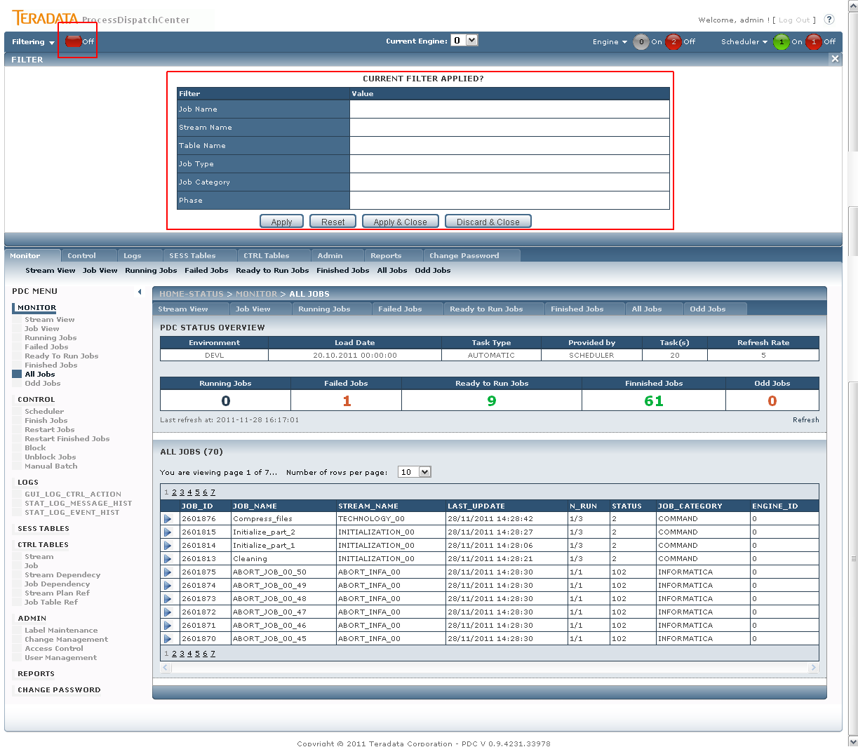
Figure 12 PDC Main Filter (not set)

Filtered content of the page (typically job listings panels) are marked with red border and flash icon in the upper right corner (css modification) – see in picture bellow.
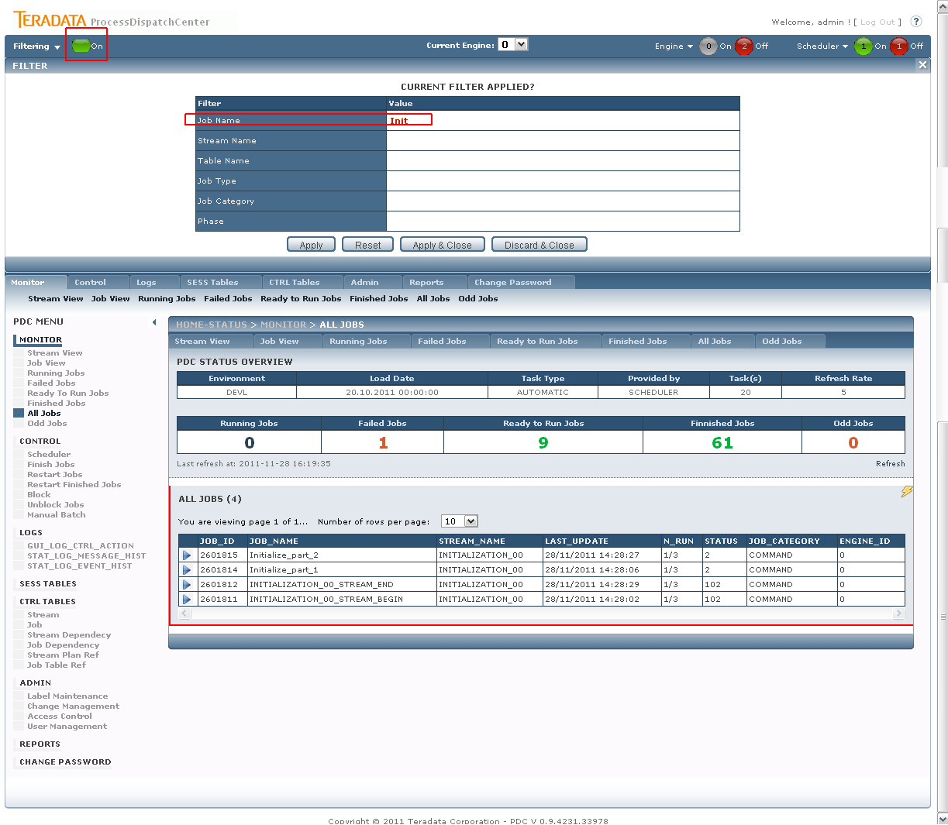
Figure 13 PDC Main Filter (not set)

The filtering itself is implemented in almost every procedure, i.e. the procedures have similar headers – with filtering parameters:

PROCEDURE SP_GUI_VIEW_CTRL_JOB(ENG_ID_IN IN INTEGER
, USER_IN IN VARCHAR2
, DEBUG_IN IN INTEGER:= 0
, FLT_STREAM_NAME_IN IN CTRL_STREAM.STREAM_NAME%TYPE
, FLT_JOB_NAME_IN IN CTRL_JOB.JOB_NAME%TYPE
, FLT_JOB_TYPE_IN IN CTRL_JOB.JOB_TYPE%TYPE
, FLT_TABLE_NAME_IN IN CTRL_JOB.TABLE_NAME%TYPE
, FLT_PHASE_IN IN CTRL_JOB.PHASE%TYPE
, FLT_JOB_CATEGORY_IN IN CTRL_JOB.JOB_CATEGORY%TYPE
, EXIT_CD_OUT OUT NOCOPY NUMBER
, ERRMSG_OUT OUT NOCOPY VARCHAR2
, ERRCODE_OUT OUT NOCOPY NUMBER
, ERRLINE_OUT OUT NOCOPY VARCHAR2
, VALUES_OUT OUT REF_GUI_CTRL_JOB);

Filter parameters (FLT_param_IN) are applied where possible as LIKE %value%:

OPEN LC_CURSOR FOR
SELECT SJ.JOB_ID
, SJ.JOB_NAME
, SJ.STREAM_NAME
, SJ.ENGINE_ID
, SJ.N_RUN || '/' || SJ.MAX_RUNS N_RUN
, SJ.LAST_UPDATE
, SJ.STATUS
, NVL(SJ.TABLE_NAME, 'N/A') TABLE_NAME
, NVL(SJ.JOB_CATEGORY, 'N/A') JOB_CATEGORY
, NVL(SJ.JOB_TYPE, 'N/A') JOB_TYPE
, NVL(SJ.PHASE, 'N/A') PHASE
FROM SESS_JOB SJ
JOIN
CTRL_JOB_STATUS CJS
ON SJ.STATUS = CJS.STATUS
WHERE SJ.ENGINE_ID = V_ENG_ID_IN
AND UPPER(NVL(SJ.STREAM_NAME, 'NA')) LIKE V_FLT_STREAM_NAME_IN
AND UPPER(NVL(SJ.JOB_NAME, 'NA')) LIKE V_FLT_JOB_NAME_IN
AND UPPER(NVL(SJ.JOB_TYPE, 'NA')) LIKE V_FLT_JOB_TYPE_IN
AND UPPER(NVL(SJ.JOB_CATEGORY, 'NA')) LIKE V_FLT_JOB_CATEGORY_IN
AND UPPER(NVL(SJ.PHASE, 'NA')) LIKE V_FLT_PHASE_IN
AND UPPER(NVL(SJ.TABLE_NAME, 'NA')) LIKE V_FLT_TABLE_NAME_IN;

Status bar
Status bar is a information bar located on the top of the page layout (see picture). The bar contains basic information as:
- Main Filter status (see chapter 3.1.12 Main Filter)
- Current (selected) engine number
- Current status of Engine and Scheduler
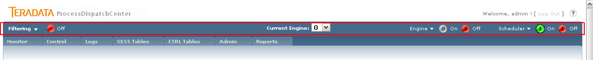
Figure 14 Status bar

The status bar implementation contains different building blocks:

Main Filter custom control
This control is described in chapter 3.1.12 Main Filter.

Engine drop drown list
User can select Engine number. The selected Engine number affects all contents in the whole PDC GUI. The selected engine is implemented as a procedure parameter in almost every procedure in the PDC.

PROCEDURE SP_GUI_VIEW_CTRL_JOB(
ENG_ID_IN IN INTEGER
, USER_IN IN VARCHAR2
, DEBUG_IN IN INTEGER:= 0
, FLT_STREAM_NAME_IN IN CTRL_STREAM.STREAM_NAME%TYPE
, FLT_JOB_NAME_IN IN CTRL_JOB.JOB_NAME%TYPE
, FLT_JOB_TYPE_IN IN CTRL_JOB.JOB_TYPE%TYPE
, FLT_TABLE_NAME_IN IN CTRL_JOB.TABLE_NAME%TYPE
, FLT_PHASE_IN IN CTRL_JOB.PHASE%TYPE
, FLT_JOB_CATEGORY_IN IN CTRL_JOB.JOB_CATEGORY%TYPE
, EXIT_CD_OUT OUT NOCOPY NUMBER
, ERRMSG_OUT OUT NOCOPY VARCHAR2
, ERRCODE_OUT OUT NOCOPY NUMBER
, ERRLINE_OUT OUT NOCOPY VARCHAR2
, VALUES_OUT OUT REF_GUI_CTRL_JOB);

The change of the current engine is trapped as drop down list control event - dropdown_PDCEngine_SelectedIndexChanged. While the value of current engine is held in session (see 3.1.2 Session object) and passed to the procedures as control parameter:

<asp:ControlParameter Name="ENG_ID_IN" Direction="Input" DefaultValue="0" DbType="String" Size="255" ControlID="dropdown_PDCEngine" PropertyName="SelectedValue" />

Engine Status custom control
Page: PDCStatEngine.ascx
Procedures:
- PCKG_GUI.SP_GUI_HEADER_ENG_STAT

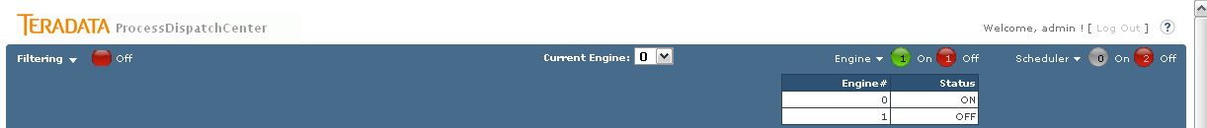
Figure 15 Engine Status expanded

Scheduler Status custom control
Page: PDCStatScheduler.ascx
Procedures:
- PCKG_GUI.SP_GUI_HEADER_SCH_STAT
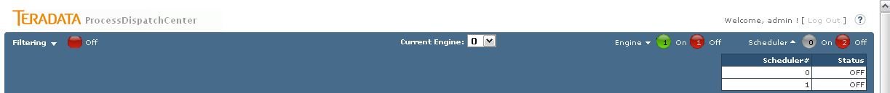
Figure 16 Scheduler Status expanded

Monitor
Monitor is used for displaying of current status of processing. The information can be presented from stream or job point of view. Drill down functionality enables drill for further details, so from stream view the user can drill down the information of how many jobs are located in the stream, what they are and what their status is. User can also drill down to parameters of selected job. On job level the user operates the job; it means he can abort running job, restart or finishing failed job and so on. Jobs and streams are divided into processing classes which represents objects state such as prepare for run, running, finished, failed and so on. The environment, load date and task type is shown as well as display refresh rate and maximal number of concurrently running jobs. The status overview part contains number of currently running jobs, number of failed jobs, number of jobs prepared for run and number of already finished jobs shows. All these numbers support drill down functionality, it means you can directly get a list of jobs in a category by clicking on the appropriate number.

Monitor – default screen
Page: Monitor.aspx
Procedures:
- PCKG_GUI.SP_GUI_VIEW_GUI_STREAM_STATS
- PCKG_GUI.SP_GUI_VIEW_GUI_JOB_STATS

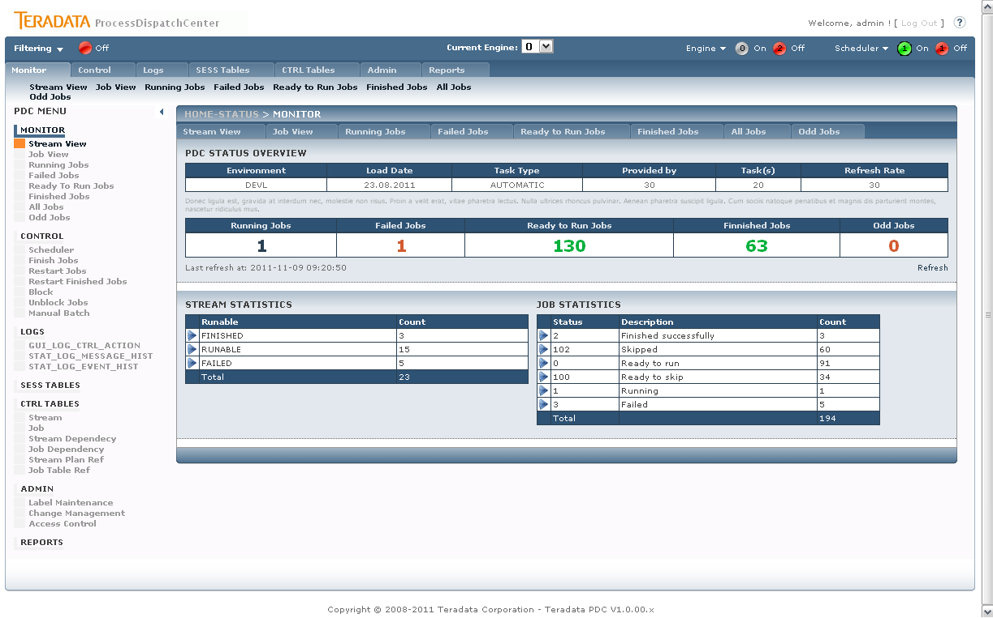
Figure 17 PDC Monitor section layout

The default Monitor screen is the Monitor.aspx page. The monitor section page layout consists of Monitor Header (PDC Status Overview) section (see chapter3.1.6 Monitor Header) and Section Related content – two grids with Stream and Job statistics.
Stream statistics grid is filled with SqlDatasource SqlDataSource_gv_Stream which points to the PCKG_GUI.SP_GUI_VIEW_GUI_STREAM_STATS procedure.
Job statistics grid is filled with SqlDatasource SqlDataSource_gv_Job which points to the PCKG_GUI.SP_GUI_VIEW_GUI_JOB_STATS procedure.
These two grids have similar functionality – give the overview of stream or job by the stream or job status. The each row can be selected for further analysis, while the selection redirects the user to the particular page and automatically shows the selected value in detail – Stream view or Job view that are described in following chapters.

Stream View
Page: MonStream.aspx
Procedures:
- PCKG_GUI.SP_GUI_VIEW_GUI_STREAM_STATS
- PCKG_GUI.SP_GUI_VIEW_GUI_STREAM_DETAILS
- SP_GUI_VIEW_GUI_STREAM_DET_1
- SP_GUI_VIEW_GUI_STREAM_DET_2
- SP_GUI_VIEW_GUI_STREAM_DET_3

Stream view section (MonStream.aspx) gives the user the overview of all streams defined with the stream status (Runnable) detail. The statuses rows are selectable and the selection can be drilled to the individual stream details (see following picture).
Figure 18 PDC Monitor – Stream view – all expanded

Panel Stream statistics contains the main grid with all streams (as in the Monitor default section) and is represented by the SqlDataSource_gv_Master calling PCKG_GUI.SP_GUI_VIEW_GUI_STREAM_STATS procedure.
Panel Stream details contains one grid (SqlDataSource_gv_Detail_lvl1) which represents the list of all Streams in selected Runnanle status (SqlDataSource_gv_Detail_lvl1) – procedure PCKG_GUI.SP_GUI_VIEW_GUI_STREAM_DETAILS.
When the user selects particular Stream the panel with the stream detailed information is revealed. The panel contains three grids that shows predefined stream info: Jobs related to the selected stream, Stream run status and Stream jobs.

Job View
Page: MonJobs.aspx
Procedures:
- PCKG_GUI.SP_GUI_VIEW_GUI_JOB_STATS
- PCKG_GUI.SP_GUI_VIEW_GUI_JOB_DETAILS
- PCKG_GUI.SP_GUI_VIEW_SESS_JOB

Job view page (MonJobs.aspx) displays the Job overview with the possibility of drilling to the individual job to see its details. The structure and function is similar to the Stream View described in previous section.
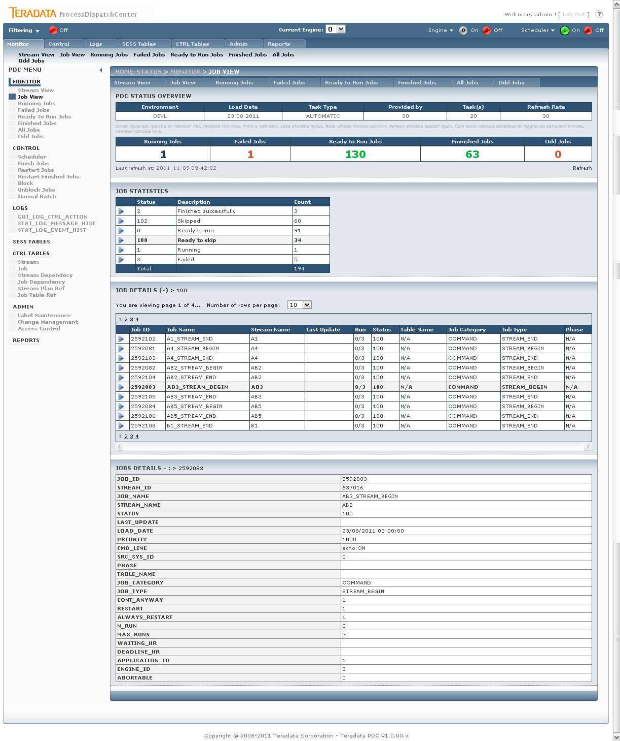
Figure 19 PDC Monitor – Job view – all expanded

Panel Job statistics contains the main grid with all jobs (as in the Monitor default section) and is represented by the SqlDataSource_gv_Master calling PCKG_GUI.SP_GUI_VIEW_GUI_JOB_STATS procedure.
Panel Job details contains one grid (SqlDataSource_gv_Detail_lvl1) which represents the list of all Jobs in selected job status (SqlDataSource_gv_Detail_lvl1) – procedure PCKG_GUI.SP_GUI_VIEW_GUI_JOB_DETAILS.
When the user selects particular Job the panel with the job detailed information is revealed. The panel contains simple list of all attributes related to the selected job.

Running Jobs
Page: MonJobsRunning.aspx
Procedures:
- PCKG_GUI.SP_GUI_VIEW_JOBS_RUNNING
- PCKG_GUI.SP_GUI_VIEW_SESS_JOB

This page represents the Running jobs. On first panel (p_Detail_lvl1) is the list of all jobs meeting the selection condition for Running jobs. Individual job can be selected in the main grid in order to see the job details.
The Job details section (p_Detail_lvl2) contains an action buttons panel (p_CONTROL) where the current buttons for the selected job are shown (according to user rights).
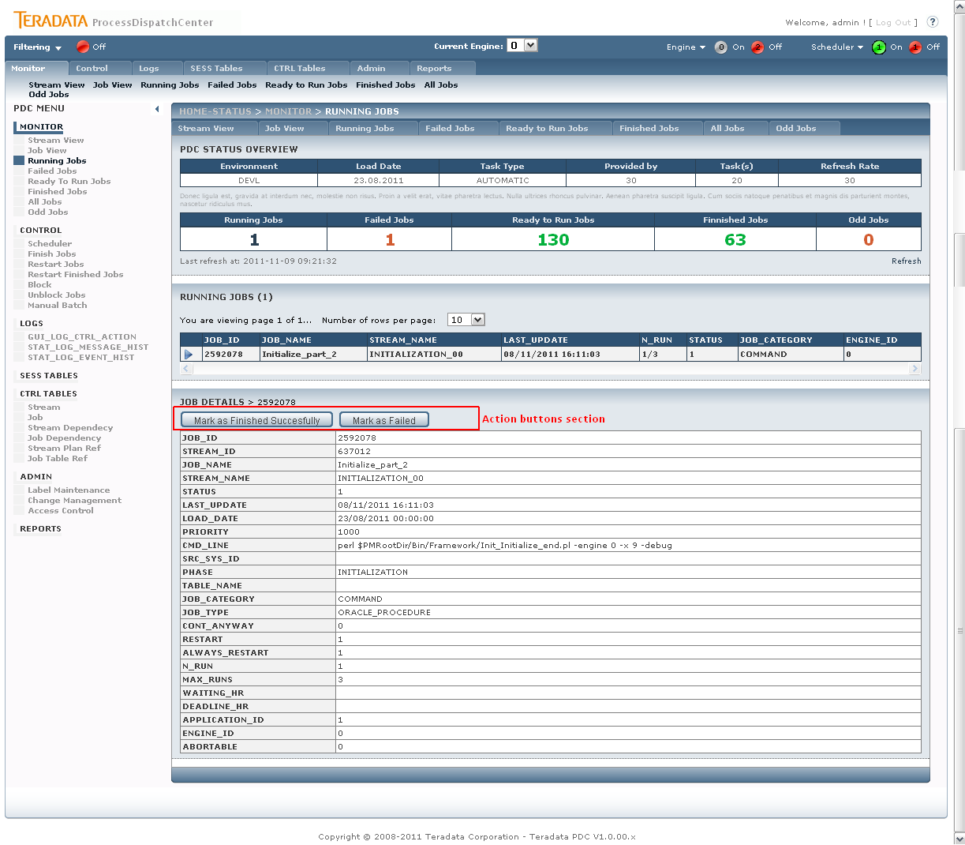
Figure 20 PDC Monitor – Running Jobs

Action buttons:
- Abort
- Mark as Finished Succesfully
- Mark as Failed

Action buttons are simple ASPX LinkButton objects. The different actions are distinguished by different CommandName parameter of LinkButton object. All commands are handled in the code behind method of each content page - public void BPDCCommandPressed(Object sender, CommandEventArgs e). This method handles all commands by simple SWITCH-CASE logic. Each branch of case calls its own database procedure.The call is made through the method public void executeJobCommandProcedure(string procedureName, string JOB_ID_parameter).

public void executeJobCommandProcedure(string procedureName, string JOB_ID_parameter)
{

using (OracleConnection objConn = new OracleConnection(ConfigurationManager.ConnectionStrings["PDCOracleConnection"].ConnectionString))
{
OracleCommand objCmd = new OracleCommand();
objCmd.Connection = objConn;
objCmd.CommandText = procedureName;
objCmd.CommandType = CommandType.StoredProcedure;

objCmd.Parameters.Add("ENG_ID_IN", OracleType.Int16, 255).Value = ((SiteMaster)Master).SelectedEngineID;
objCmd.Parameters.Add("USER_IN", OracleType.VarChar, 255).Value = ((SiteMaster)Master).GetUserName;

objCmd.Parameters.Add("DEBUG_IN", OracleType.VarChar, 255).Value = 0; //TODO
objCmd.Parameters.Add("EXIT_CD_OUT", OracleType.Number).Direction = ParameterDirection.Output;
objCmd.Parameters.Add("ERRMSG_OUT", OracleType.VarChar, 255).Direction = ParameterDirection.Output;
objCmd.Parameters.Add("ERRCODE_OUT", OracleType.VarChar, 255).Direction = ParameterDirection.Output;
objCmd.Parameters.Add("ERRLINE_OUT", OracleType.VarChar, 255).Direction = ParameterDirection.Output;

objCmd.Parameters.Add("JOB_ID_IN", OracleType.VarChar, 255).Value = JOB_ID_parameter;

try
{
objConn.Open();
objCmd.ExecuteNonQuery();
((SiteMaster)Master).handleProcedureErrorOutput(objCmd.Parameters, true);
((SiteMaster)Master).showFinalInfoInPanel();
}
catch (Exception ex)
{
((SiteMaster)Master).displayInfo("Proc [" + procedureName + "] failed with error:<br>" + ex.ToString());
}

}
}

Failed Jobs
Page: MonJobsFailed.aspx
Procedures:
- PCKG_GUI.SP_GUI_VIEW_JOBS_FAILED
- PCKG_GUI.SP_GUI_VIEW_SESS_JOB

This page represents the Failed jobs. On first panel (p_Detail_lvl1) is the list of all jobs meeting the selection condition for Failed jobs. Individual job can be selected in the main grid in order to see the job details.
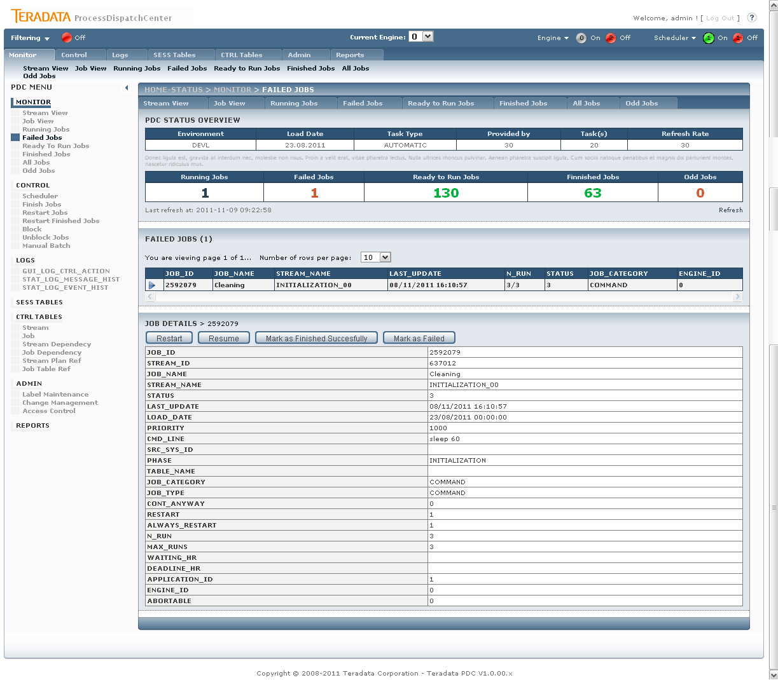
Figure 21 PDC Monitor – Failed Jobs

The implementation of this page is similar to section Running jobs described in previous chapter - 3.2.4 Running Jobs.
Action buttons:
- Restart
- Resume
- Mark as Finished Successfully
- Mark as Failed

Ready to Run Jobs
Page: MonJobsReady.aspx
Procedures:
- PCKG_GUI.SP_GUI_VIEW_JOBS_READY_TO_RUN
- PCKG_GUI.SP_GUI_VIEW_SESS_JOB

This page represents the Ready to Run jobs. On first panel (p_Detail_lvl1) is the list of all jobs meeting the selection condition for Ready to Run jobs. Individual job can be selected in the main grid in order to see the job details.

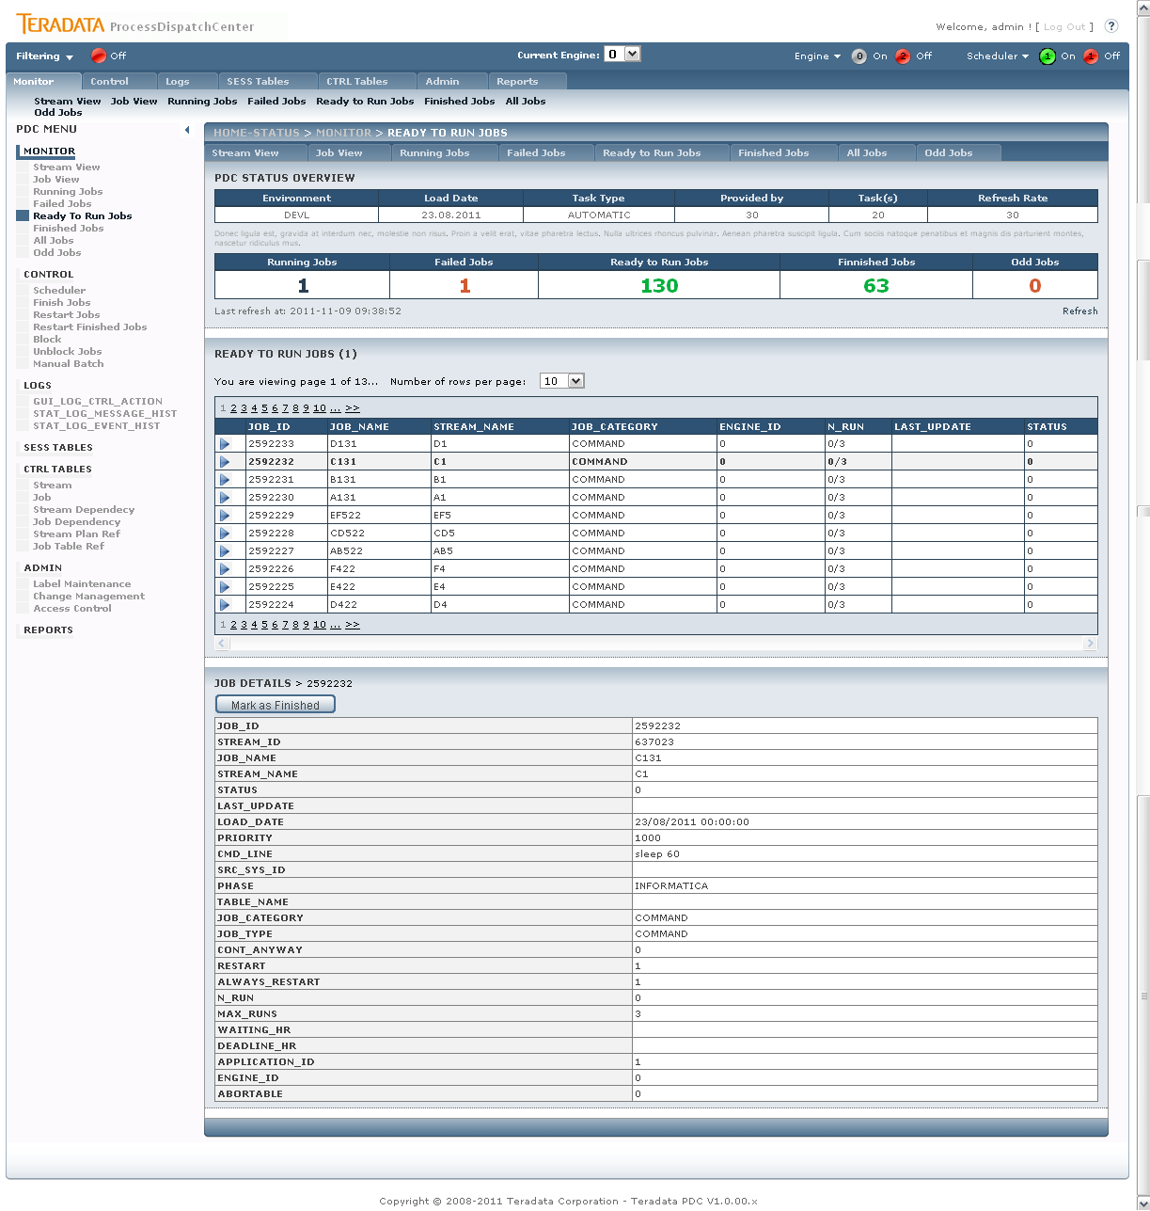
Figure 22 PDC Monitor – Ready to Run Jobs

The implementation of this page is similar to section Running jobs described in previous chapter - 3.2.4 Running Jobs.
Action buttons:
- Mark as Finished

Finished Jobs
Page: MonJobsFinished.aspx
Procedures:
- PCKG_GUI.SP_GUI_VIEW_JOBS_FINISHED
- PCKG_GUI.SP_GUI_VIEW_SESS_JOB

This page represents the Finished jobs. On first panel (p_Detail_lvl1) is the list of all jobs meeting the selection condition for Finished jobs. Individual job can be selected in the main grid in order to see the job details.

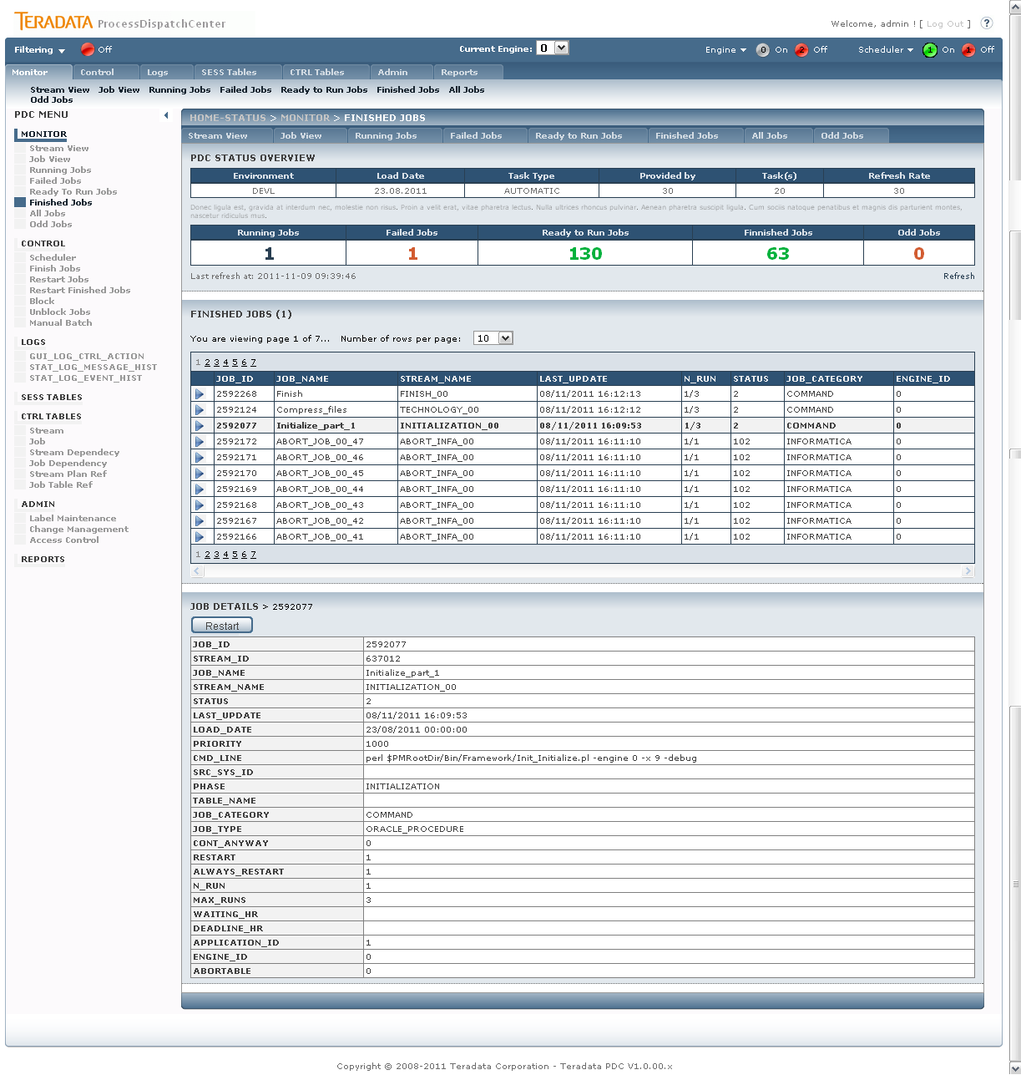
Figure 23 PDC Monitor – Finished Jobs

The implementation of this page is similar to section Running jobs described in previous chapter - 3.2.4 Running Jobs.
Action buttons:
- Restart

All Jobs
Page: MonJobsAll.aspx
Procedures:
- PCKG_GUI. SP_GUI_VIEW_JOBS_ALL
- PCKG_GUI.SP_GUI_VIEW_SESS_JOB

This page represents the All jobs – all jobs within the PDC. On first panel (p_Detail_lvl1) is the list of all jobs. Individual job can be selected in the main grid in order to see the job details.

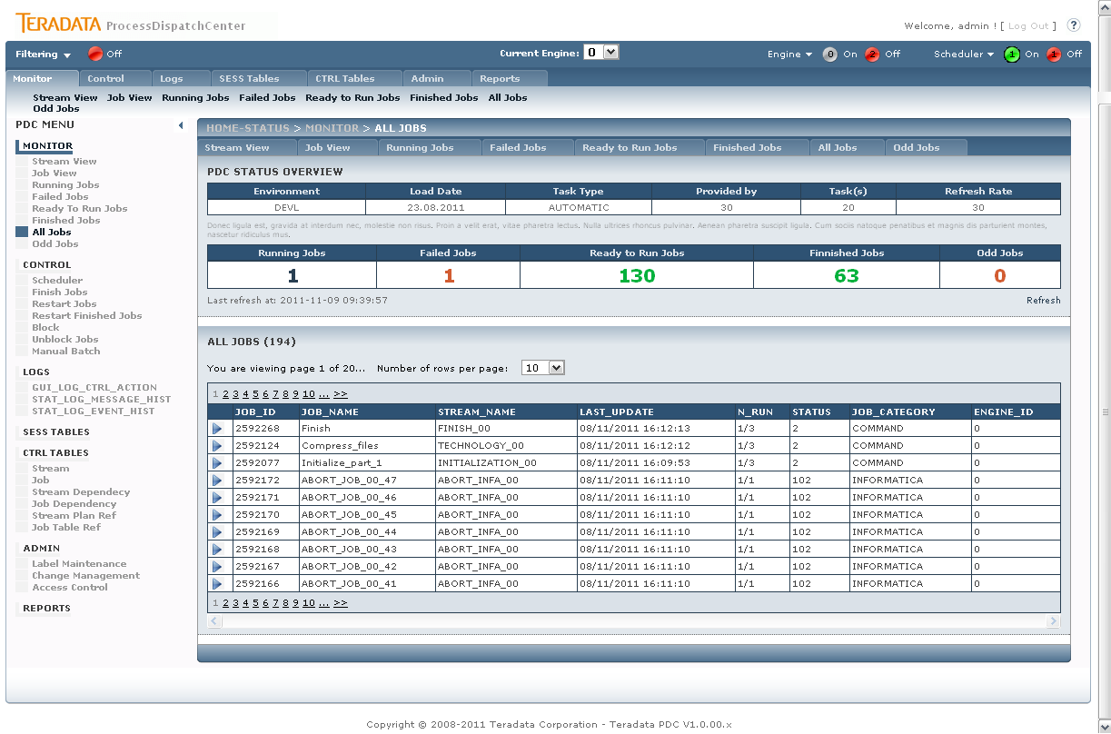
Figure 24 PDC Monitor – All Jobs

The implementation of this page is similar to section Running jobs described in previous chapter - 3.2.4 Running Jobs, except that there are no action buttons.

Odd Jobs
Page: MonJobsOdd.aspx
Procedures:
- PCKG_GUI.SP_GUI_VIEW_JOBS_ODD
- PCKG_GUI.SP_GUI_VIEW_SESS_JOB

This page represents the Odd jobs. On first panel (p_Detail_lvl1) is the list of all jobs meeting the selection condition for Odd jobs. Individual job can be selected in the main grid in order to see the job details.

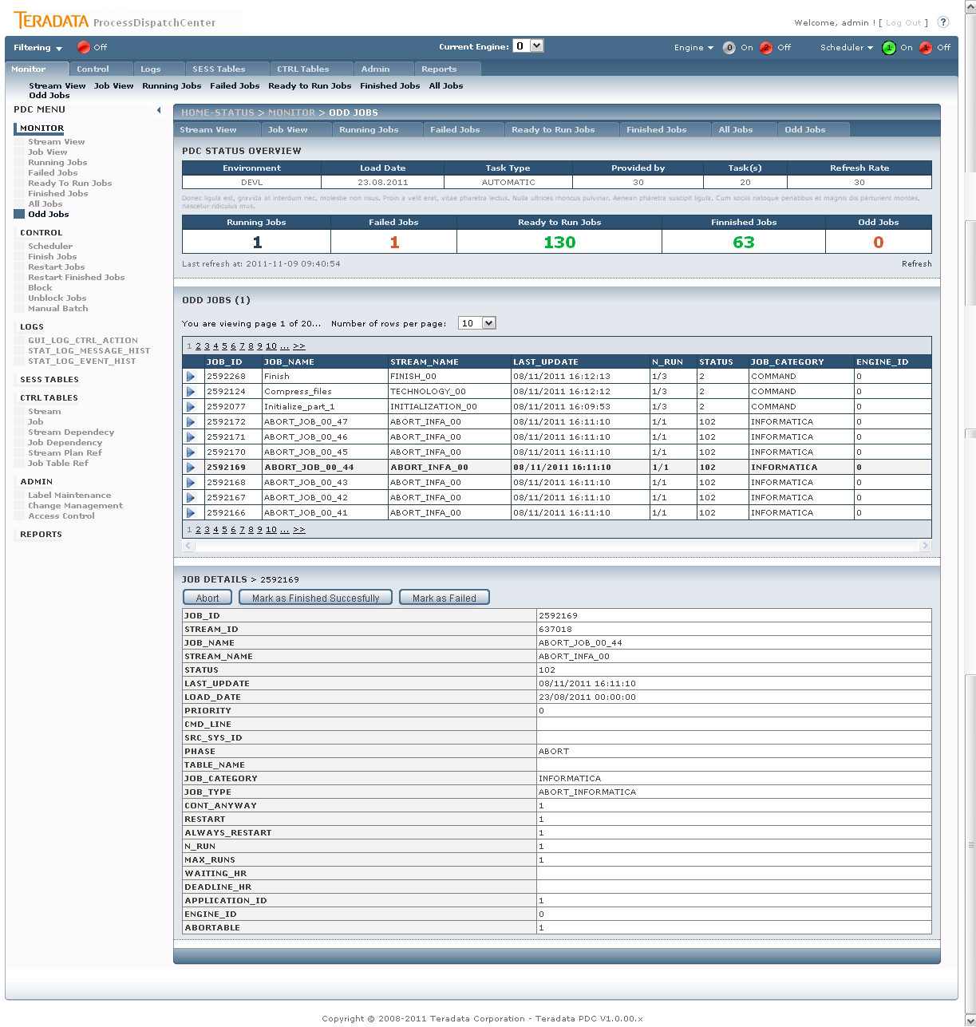
Figure 25 PDC Monitor – Odd Jobs

The implementation of this page is similar to section Running jobs described in previous chapter - 3.2.4 Running Jobs.
Action buttons:
- Abort
- Mark as Finished Succesfully
- Mark as Failed

Control
Control enables access to all necessary settings used for controlling of PDC application. Same basic functionality for job processing is also located on the monitor part, but Control part enables driving parallelisms, temporary stop the Scheduler or doing control task on job level simultaneously for group of jobs. User can also simply stop executing jobs on selected dependency branch by blocking its parent job. Manual Batch functionality enables recalculation of selected jobs for chosen load date. It’s often used for datamarts recalculation for the day.

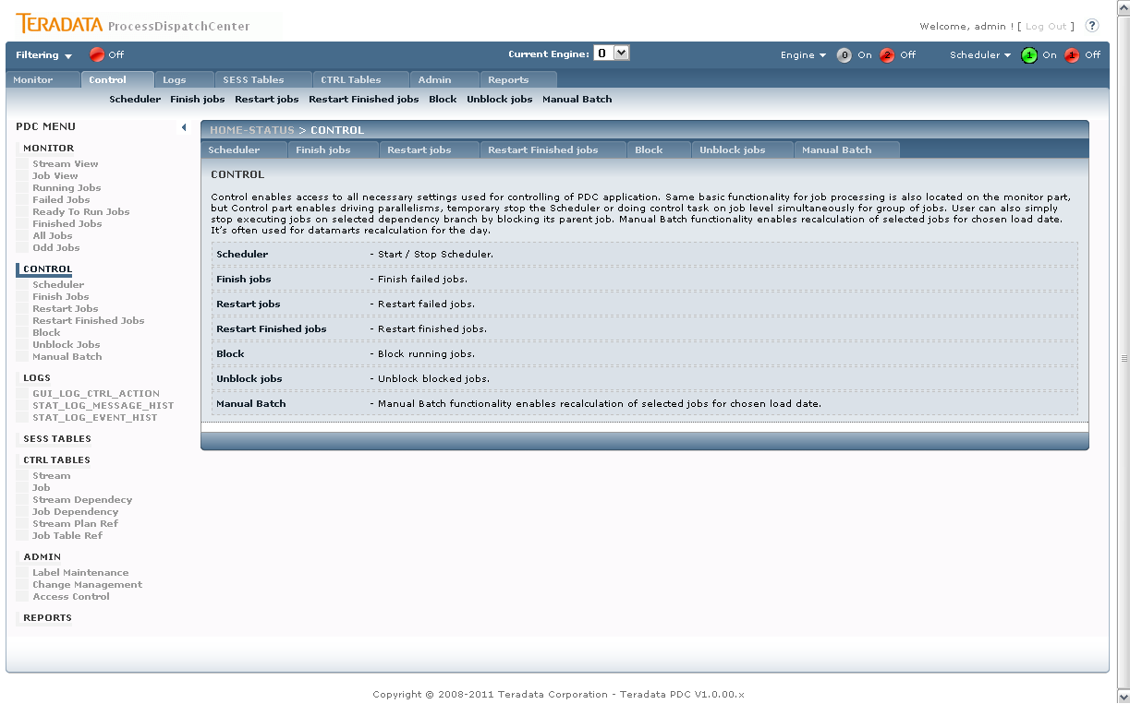
Figure 26 PDC Control

Scheduler
Page: ControlScheduler.aspx
Procedures:
- PCKG_GUI.SP_GUI_VIEW_CTRL_SCHED_NUM_JOB

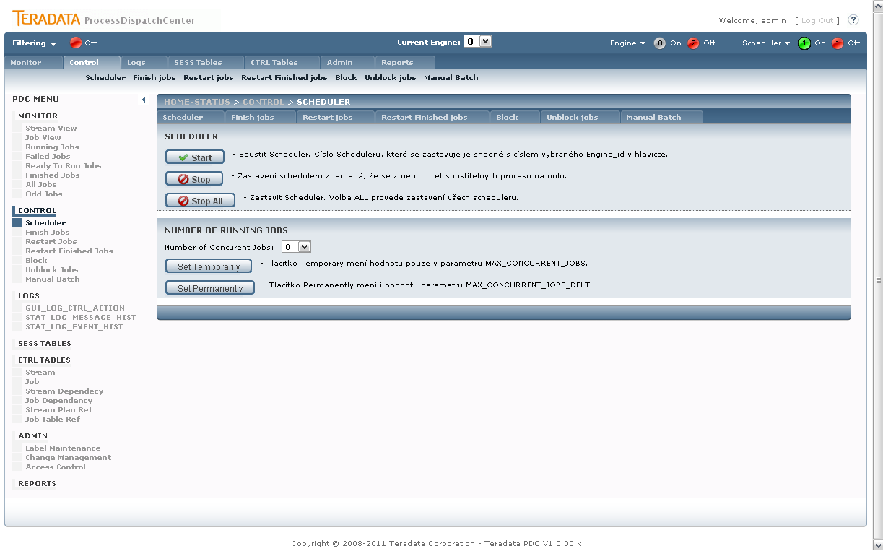
Figure 27 PDC Control – Scheduler

The page provides the user with control of Scheduler.

Button Start
Type: LinkButton
Command: COMMAND_SCHED_START
Procedures:
- PCKG_GUI.

Start of Scheduler. This action returns Scheduler possibility supply jobs to Engine for launching. The engine_id number of Scheduler is taken from Status Bar value of Current Engine.

Button Stop
Type: LinkButton
Command: COMMAND_SCHED_STOP
Procedures:
- PCKG_GUI.SP_GUI_SCHEDULER_STOP

Stop of Scheduler. This action removes Scheduler possibility to choose jobs for processing. Factually this action set value of number of concurrent running jobs to zero. No action is applied on already running jobs. The engine_id number of Scheduler is taken from Status Bar value of Current Engine.
The button is calling the procedure and passing parameter STOP_ALL_IN set to NO.

objCmd.Parameters.Add("STOP_ALL_IN", OracleType.VarChar, 255).Value = "N";

Button Stop All
Type: LinkButton
Command: COMMAND_SCHED_STOP_ALL
Procedures:
- PCKG_GUI.SP_GUI_SCHEDULER_STOP

The button stops all schedulers. The button is calling the same procedure as Button Stop and passing parameter STOP_ALL_IN set to YES.

objCmd.Parameters.Add("STOP_ALL_IN", OracleType.VarChar, 255).Value = "Y";

DropDown Number of Concurrent Jobs
Type: DropDown
Procedures:
- PCKG_GUI.SP_GUI_VIEW_CTRL_SCHED_NUM_JOB

Sets the maximal number of concurrently running jobs. The action event is not auto-fired – it is bound with following buttons (whether to set temporarily or permanently).

Button Set Temporarily
Type: LinkButton
Command: COMMAND_SCHED_NUM_JOB_TEM
Procedures:
- PCKG_GUI.SP_GUI_SCHEDULER_NUM_JOB_TEMP

Sets the number of concurrent jobs temporarily, it means for current job processing. Next day initialization returns the value of concurrently running jobs to default. The engine_id number of Scheduler is taken from Status Bar value of Current Engine.

Button Set Permanently
Type: LinkButton
Command: COMMAND_SCHED_NUM_JOB_PERM
Procedures:
- PCKG_GUI.SP_GUI_SCHEDULER_NUM_JOB_PERM

Sets the number of concurrent jobs permanently, it means that also default is changed. The engine_id number of Scheduler is taken from Status Bar value of Current Engine.

Finish Jobs
Page: ControlFinish.aspx
Procedures:
- PCKG_GUI.SP_GUI_VIEW_JOBS_FAILED_ONLY
- PCKG_GUI.SP_GUI_JOB_FINISH

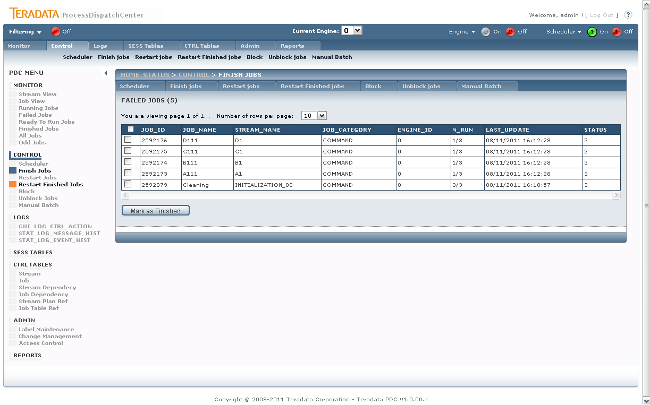
Figure 28 Control – Finish Jobs

The page serves for batch marking available (Failed Jobs here) jobs to the desired status (here as Finished Jobs). In order to provide this functionality the page is implemented as simple paged GridView which is filled with the available job for the operation (PCKG_GUI.SP_GUI_VIEW_JOBS_FAILED_ONLY).
The available jobs can be checked selectively or all jobs on the visible page (by checking the header check box) – this is implemented by client side script that is included in this page’s asp:Content header tag.

<asp:Content ID="Content1" ContentPlaceHolderID="HeadContent" runat="server">
<script type="text/javascript">
function ChangeCheckBoxState(id, checkState) {
var cb = document.getElementById(id);
if (cb != null)
cb.checked = checkState;
}

function ChangeAllCheckBoxStates(checkState) {
// Toggles through all of the checkboxes defined in the CheckBoxIDs array
// and updates their value to the checkState input parameter
if (CheckBoxIDs != null) {
for (var i = 0; i < CheckBoxIDs.length; i++)
ChangeCheckBoxState(CheckBoxIDs[i], checkState);
}
}
</script>
</asp:Content>

The marking button is ASPX LinkButton objects that fires the desired action procedure with its CommandName parameter. The parameter is catched in the button event handling method and the desired procedure is fired for each selected job.

/// <summary>
/// Used for custom buttons in the page.
/// </summary>
/// <param name="sender"></param>
/// <param name="e"></param>
public void BPDCCommandPressed(Object sender, CommandEventArgs e)
{
// Iterate through the Products.Rows property
foreach (GridViewRow row in gv_Detail_lvl1.Rows)
{
// Access the CheckBox
CheckBox cb = (CheckBox)row.FindControl("RowLevelCheckBox");
if (cb != null && cb.Checked)
{
checkedRows++;
switch (e.CommandName)
{
...
case "COMMAND_JOB_FINISH": //COMMAND_JOB_FINISH
executeJobCommandProcedure("PCKG_GUI.SP_GUI_JOB_FINISH", gv_Detail_lvl1.DataKeys[row.RowIndex].Value.ToString());
break;
...
default:
break;

}
}
}
((SiteMaster)Master).showFinalInfoInPanel();
gv_Detail_lvl1.DataBind();
}

The user is given the information in something goes wrong via the Info Panel (see 3.1.10 Info Panel).

Restart Jobs
Page: ControlRestart.aspx
Procedures:
- PCKG_GUI.SP_GUI_VIEW_JOBS_FAILED
- PCKG_GUI.SP_GUI_JOB_RESTART

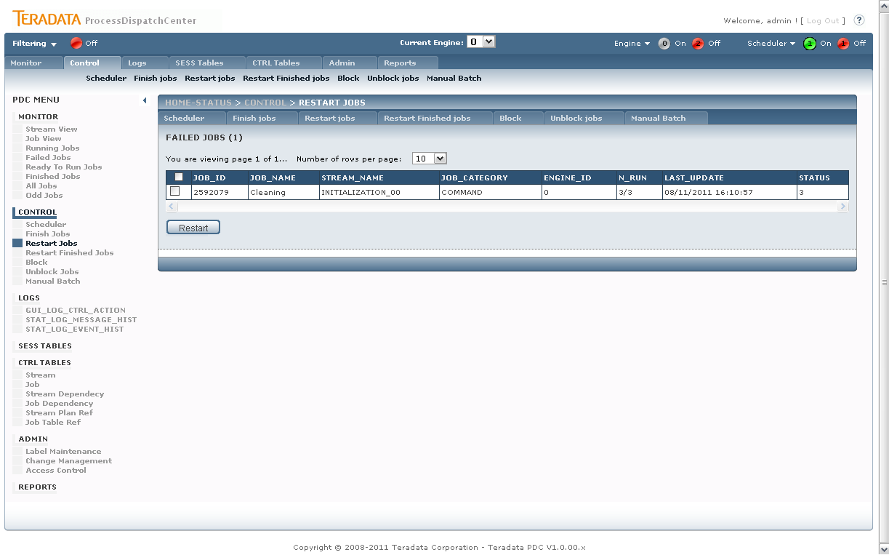
Figure 29 Control – Restart Jobs

The page provides functionality of batch-marking jobs to desired job status. The implementation is similar to Control Finish Jobs (see 3.3.2 Finish Jobs), except the available job procedure or/and the action button procedure (see procedures for this section).

Restart Finished Jobs
Page: ControlRestartFinished.aspx
Procedures:
- PCKG_GUI.SP_GUI_VIEW_JOBS_FINISHED
- PCKG_GUI.SP_GUI_JOB_RESTART

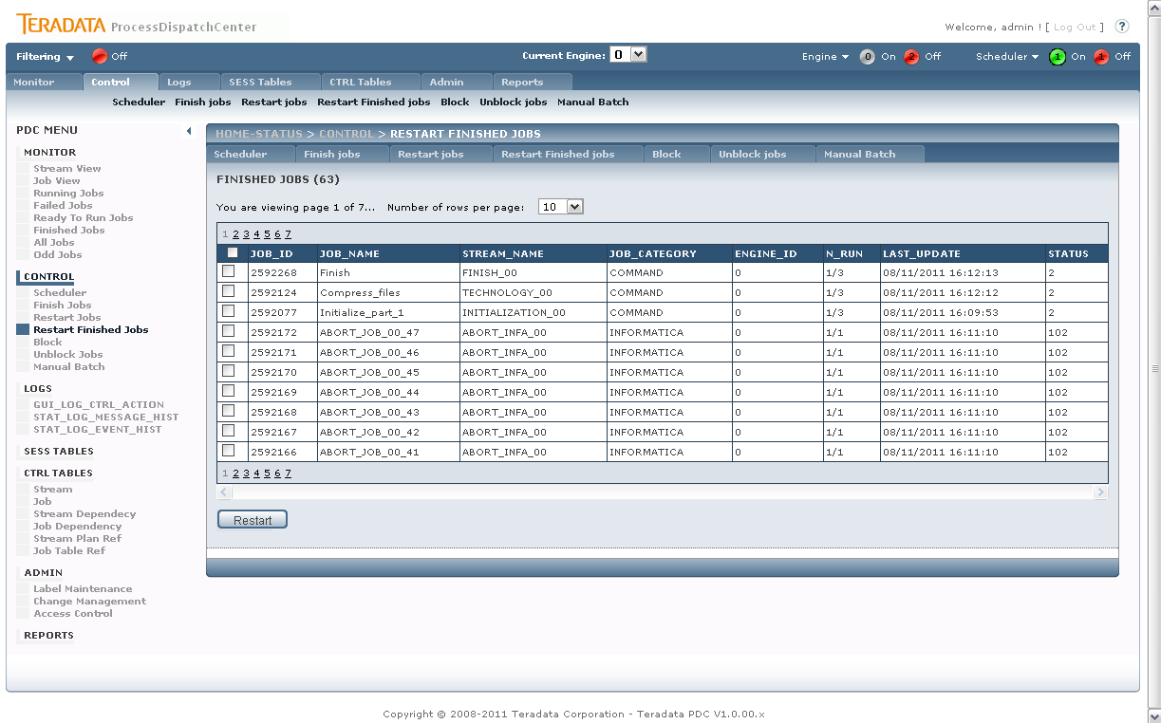
Figure 30 Control – Restart Finished Jobs

The page provides functionality of batch-marking jobs to desired job status. The implementation is similar to Control Finish Jobs (see 3.3.2 Finish Jobs), except the available job procedure or/and the action button procedure (see procedures for this section).

Block
Page: ControlBlock.aspx
Procedures:
- PCKG_GUI.SP_GUI_VIEW_JOBS_UNBLOCKED
- PCKG_GUI.SP_GUI_JOB_BLOCK

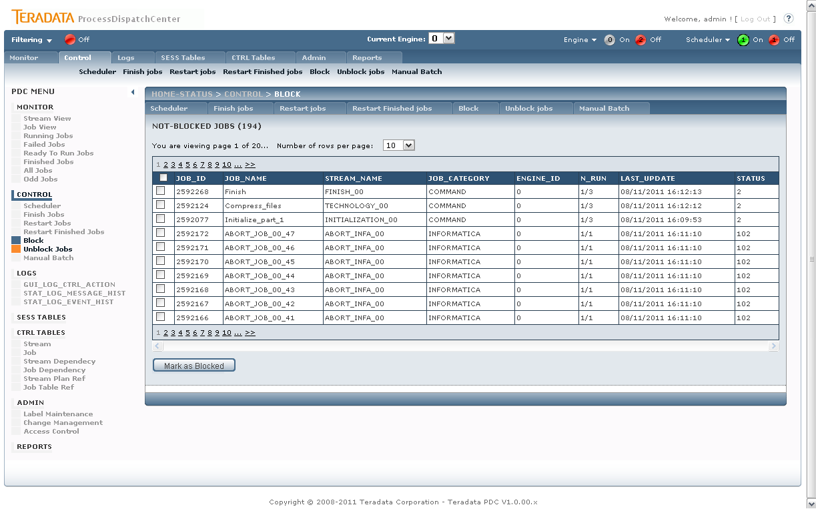
Figure 31 Control – Block Jobs

The page provides functionality of batch-marking jobs to desired job status. The implementation is similar to Control Finish Jobs (see 3.3.2 Finish Jobs), except the available job procedure or/and the action button procedure (see procedures for this section).

Unblock Jobs
Page: ControlUnblock.aspx
Procedures:
- PCKG_GUI.SP_GUI_VIEW_JOBS_BLOCKED
- PCKG_GUI.SP_GUI_JOB_UNBLOC

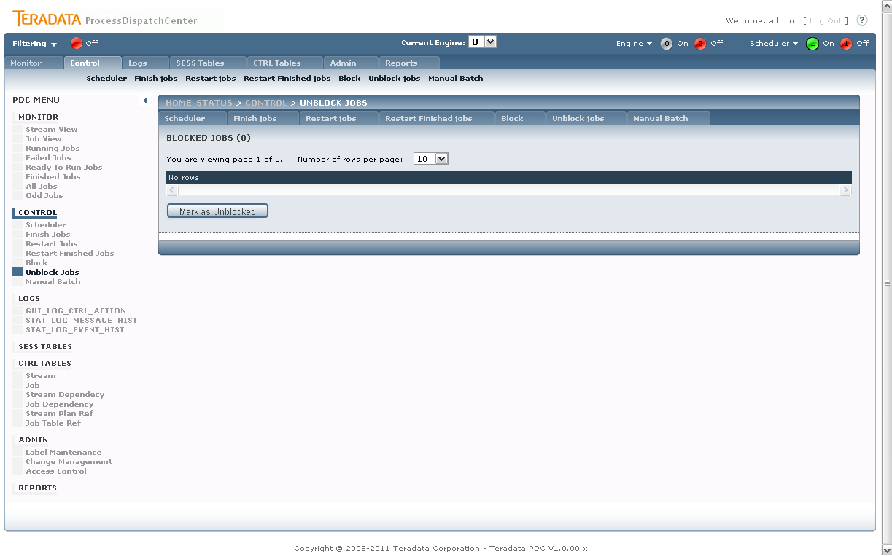
Figure 32 Control – Unblock Jobs

The page provides functionality of batch-marking jobs to desired job status. The implementation is similar to Control Finish Jobs (see 3.3.2 Finish Jobs), except the available job procedure or/and the action button procedure (see procedures for this section).

Manual Batch
Manual Batch functionality enables recalculation of selected jobs for chosen load date. It’s often used for datamarts recalculation for the day.
Manual Batch section is divided into several steps that follows the manual batch workflow.
- Step 0: Start Check
- Step 1: Select date and description (Init)
- Step 2: Choose jobs for Manual Batch
- Step 3: Operate Manual Batch (Start/Stop)
The page GUI is also divided according to Manual Batch steps into several panel tat are revealed or hided according to current step of user Manual Batch settings:
- P_Manual_Init
- P_Manual_Init_Done
- p_Detail_lvl1
- p_Manual_Buttons
  - LBManBatchStart
  - LBManBatchCancel
  - LBManBatchFinish
- p_Manual_FinishRunning

Step 0: Start Check
This initial step performs the initial check to the PDC database by calling the SP_GUI_MBATCH_STRTCHCK procedure.

PROCEDURE SP_GUI_MBATCH_STRTCHCK(ENG_ID_IN IN INTEGER
, USER_IN IN VARCHAR2
, DEBUG_IN IN INTEGER:= 0
, EXIT_CD_OUT OUT NOCOPY NUMBER
, ERRMSG_OUT OUT NOCOPY VARCHAR2
, ERRCODE_OUT OUT NOCOPY NUMBER
, ERRLINE_OUT OUT NOCOPY VARCHAR2)

The result is stored in the EXIT_CD_OUT parameter. Where 0 represents success, otherwise the parameter is set to value bellow zero.
If the start check is successful the user proceed immediately to the next step (see picture bellow) and the panel p_Manual_Init is visible.

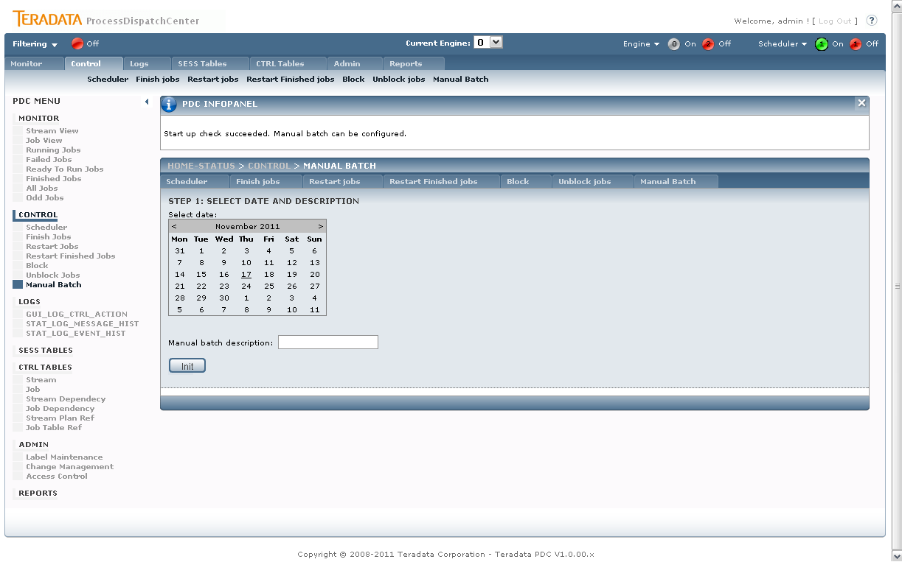
Figure 33 Manual Batch – Step 0

Step 1: Init
This phase allows PDC user to set particular Manual Batch Date and Description. The Date is set directly from the clickable calendar.
After defining the basic values, user can proceed to the init phase by clicking the Init button (see image above). This button calls underlying procedure SP_GUI_MBATCH_STINIT:
PROCEDURE SP_GUI_MBATCH_STINIT(ENG_ID_IN IN INTEGER
, USER_IN IN VARCHAR2
, DEBUG_IN IN INTEGER:= 0
, EXIT_CD_OUT OUT NOCOPY NUMBER
, ERRMSG_OUT OUT NOCOPY VARCHAR2
, ERRCODE_OUT OUT NOCOPY NUMBER
, ERRLINE_OUT OUT NOCOPY VARCHAR2
, MAN_BATCH_LD_IN IN OUT NOCOPY VARCHAR2
, MAN_BATCH_DESC_IN IN OUT NOCOPY LKP_APPLICATION.DESCRIPTION%TYPE)

On succesfull Init the user procedd to the next phase – selecting jobs to Manual Batch and the panel p_Detail_lvl1is now visible to the user.

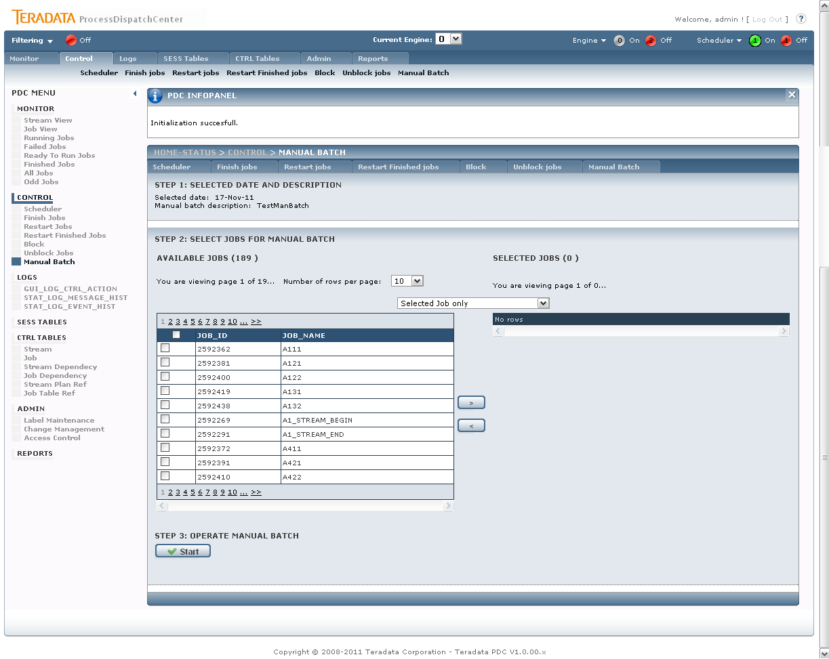 Figure 34 Manual Batch – Step 1

Step 2: Job selection
In this step the user can select the jobs for manual batch. The user can select the jobs from the Available jobs table (see figure). The jobs can be selected with four option (in the combo box):
- Selected Job only
- Selected and Children
- Selected and Parents
- Selected and Parents and Children

The selected jobs are located in the right table – selected jobs table. The selected jobs can be removed from the selection.

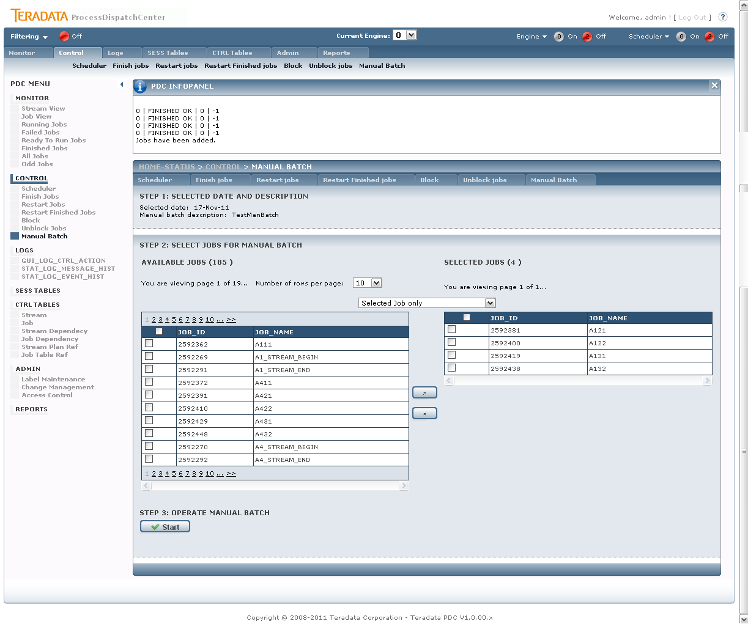 Figure 35 Manual Batch – Job Selection

The Job selection and remove is done by calling appropriate procedures - SP_GUI_MBATCH_SETEXE and SP_GUI_MBATCH_UNSETEXE.
PROCEDURE SP_GUI_MBATCH_SETEXE(ENG_ID_IN IN INTEGER
, USER_IN IN VARCHAR2
, JOB_ID_IN VARCHAR2
, DEBUG_IN IN INTEGER:= 0
, EXIT_CD_OUT OUT NOCOPY NUMBER
, ERRMSG_OUT OUT NOCOPY VARCHAR2
, ERRCODE_OUT OUT NOCOPY NUMBER
, ERRLINE_OUT OUT NOCOPY VARCHAR2
, REQUEST_ACC_IN IN INTEGER)

PROCEDURE SP_GUI_MBATCH_UNSETEXE(ENG_ID_IN IN INTEGER
, USER_IN IN VARCHAR2
, JOB_ID_IN VARCHAR2
, DEBUG_IN IN INTEGER:= 0
, EXIT_CD_OUT OUT NOCOPY NUMBER
, ERRMSG_OUT OUT NOCOPY VARCHAR2
, ERRCODE_OUT OUT NOCOPY NUMBER
, ERRLINE_OUT OUT NOCOPY VARCHAR2)

The two table are filled with procedures SP_GUI_MBATCH_AVAIL_JBS for Available Jobs and SP_GUI_MBATCH_SEL_JBS for selected Jobs.
PROCEDURE SP_GUI_MBATCH_AVAIL_JBS(ENG_ID_IN IN INTEGER
, USER_IN IN VARCHAR2
, DEBUG_IN IN INTEGER:= 0
, FLT_STREAM_NAME_IN IN VARCHAR2
, FLT_JOB_NAME_IN IN VARCHAR2
, FLT_JOB_TYPE_IN IN VARCHAR2
, FLT_TABLE_NAME_IN IN VARCHAR2
, FLT_PHASE_IN IN VARCHAR2
, FLT_JOB_CATEGORY_IN IN VARCHAR2
, EXIT_CD_OUT OUT NOCOPY NUMBER
, ERRMSG_OUT OUT NOCOPY VARCHAR2
, ERRCODE_OUT OUT NOCOPY NUMBER
, ERRLINE_OUT OUT NOCOPY VARCHAR2
, VALUES_OUT OUT REF_MAN_BATCH_AV)

PROCEDURE SP_GUI_MBATCH_SEL_JBS(ENG_ID_IN IN INTEGER
, USER_IN IN VARCHAR2
, DEBUG_IN IN INTEGER:= 0
, FLT_STREAM_NAME_IN IN VARCHAR2
, FLT_JOB_NAME_IN IN VARCHAR2
, FLT_JOB_TYPE_IN IN VARCHAR2
, FLT_TABLE_NAME_IN IN VARCHAR2
, FLT_PHASE_IN IN VARCHAR2
, FLT_JOB_CATEGORY_IN IN VARCHAR2
, EXIT_CD_OUT OUT NOCOPY NUMBER
, ERRMSG_OUT OUT NOCOPY VARCHAR2
, ERRCODE_OUT OUT NOCOPY NUMBER
, ERRLINE_OUT OUT NOCOPY VARCHAR2
, VALUES_OUT OUT REF_MAN_BATCH_SEL)

Step 3: Operate Manual Batch
Thee final step is to operate the Manual Batch – Start or Stop the Manual Batch. The user is provided with buttons that are located in the panel p_Manual_Buttons which is visible from previous steps.
The Start button calls procedure SP_GUI_MBATCH_SETSTART which handles the Manual Batch start:

PROCEDURE SP_GUI_MBATCH_SETSTART(ENG_ID_IN IN INTEGER
, USER_IN IN VARCHAR2
, DEBUG_IN IN INTEGER:= 0
, EXIT_CD_OUT OUT NOCOPY NUMBER
, ERRMSG_OUT OUT NOCOPY VARCHAR2
, ERRCODE_OUT OUT NOCOPY NUMBER
, ERRLINE_OUT OUT NOCOPY VARCHAR2)

The Finish button stops the current Manual Batch process by calling SP_GUI_MBATCH_SETFIN procedure:

PROCEDURE SP_GUI_MBATCH_SETFIN(ENG_ID_IN IN INTEGER
, USER_IN IN VARCHAR2
, DEBUG_IN IN INTEGER:= 0
, EXIT_CD_OUT OUT NOCOPY NUMBER
, ERRMSG_OUT OUT NOCOPY VARCHAR2
, ERRCODE_OUT OUT NOCOPY NUMBER
, ERRLINE_OUT OUT NOCOPY VARCHAR2)

The modified page layout is show in the following figure.
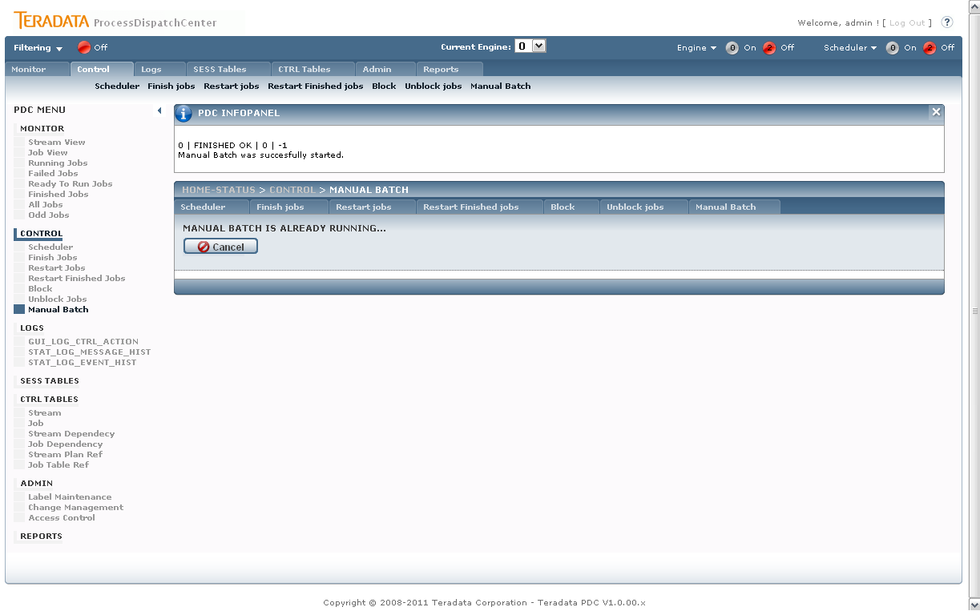
Figure 36 Manual Batch – Job Selection

Logs
Logs display controlling steps done on PDC application – it enables potential supervisor cooperation on problem solving, and also all problems captured by Framework checker application.
There are three log pages implemented:
- GUI_LOG_CTRL_ACTION
- STAT_LOG_MESSAGE_HIST
- STAT_LOG_EVENT_HIST
All pages are implemented similar – they only display a GridView which is filled with all log entries.
Procedures:
- PCKG_GUI.SP_GUI_VIEW_LOGS_LOGCTRLACTION
- PCKG_GUI.SP_GUI_VIEW_LOGS_STTLOGEVNTHST
- PCKG_GUI.SP_GUI_VIEW_LOGS_STATLOGMSSHST

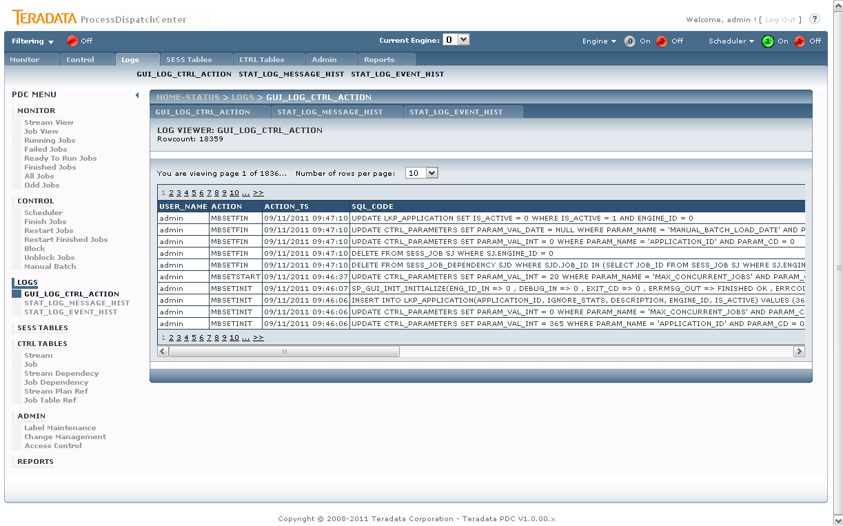
Figure 37 Sample Log page

Session Tables
SESS (session) tables contain production metadata and store actual status of objects. SESS TABLES part enables changes in the table content. Such change can represent increasing actual job priority, command line changes and so on.
Session tables section contains only SESS_JOB table. Only defined set of fields of the job can be edited:
- LAST_UPDATE (nullable only – see bellow)
- PRIORITY
- CMD_LINE

Page: SessTables.aspx
Procedures:
- PCKG_GUI.SP_GUI_VIEW_SESS_JOB_AL
- PCKG_GUI.SP_GUI_UPDT_SESS_JOB

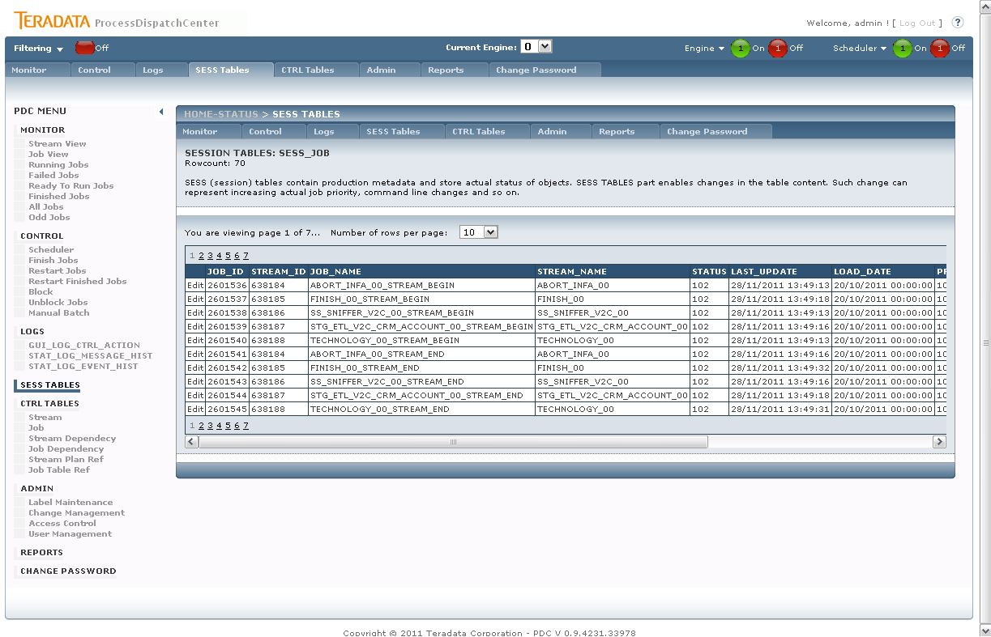
Figure 38 Session Tables

The field LAST_UPDATE can be only set to NULL (or leave as is). This is done by template field – drop down list for editing – in ASPX where the value of NULL is given on RowUpdate event:
<asp:TemplateField SortExpression="LAST_UPDATE" HeaderText="LAST_UPDATE" >
<EditItemTemplate>
<asp:DropDownList ID="DDListLAST_UPDATE" Runat="server" AppendDataBoundItems="True">
</asp:DropDownList>
<asp:Label Runat="server" Text='<%# Bind("LAST_UPDATE") %>' ID="Label1"></asp:Label>
</EditItemTemplate>
<ItemTemplate >
<asp:Label Runat="server" Text='<%# Bind("LAST_UPDATE") %>' ID="Label1"></asp:Label>
</ItemTemplate>
</asp:TemplateField>

CTRL Tables
CTRL (control) tables store configuration metadata of jobs, streams, their dependences, locks and calendars. This part of GUI application is used for creating or changing this metadata. Application automatically checks correctness of typed values. Changes are enabled only when a label is selected which is necessary for change management process package creation.

Page: CtrlTables.aspx
Procedures:
- PCKG_GUI.SP_GUI_VIEW_CHM

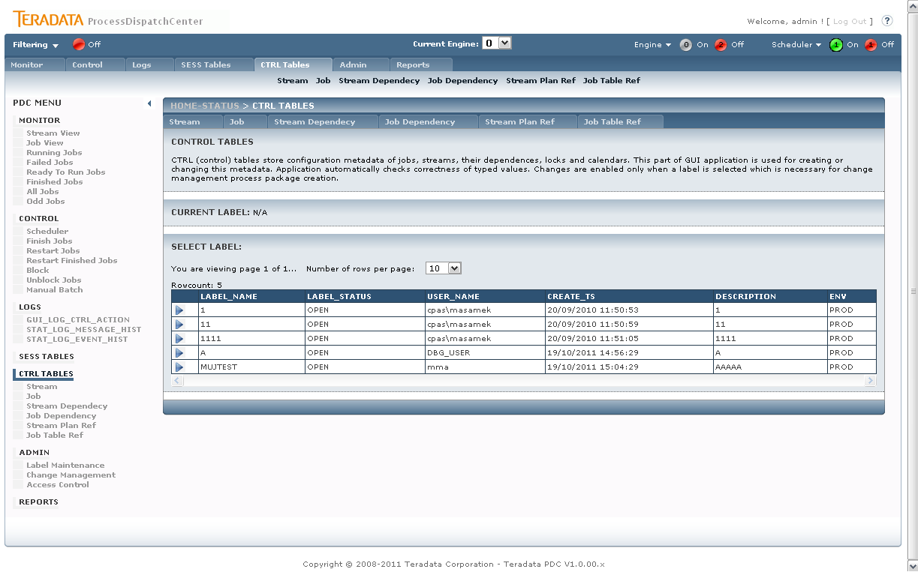
Figure 39 Control Tables – Label selection

The section only lists all LABELs in status OPEN. The user have to select the label in order to work with following section of CTRL TABLES. The selected label is stored in Session (see chapter 3.1.2Session object).

Stream
Page: CTRL_STREAM.aspx
Procedures:
- PCKG_GUI.SP_GUI_VIEW_CTRL_STREAM
- PCKG_GUI.SP_GUI_UPDT_CTRL_STREAM
- PCKG_GUI.SP_GUI_UPDT_CTRL_STREAM_DEL

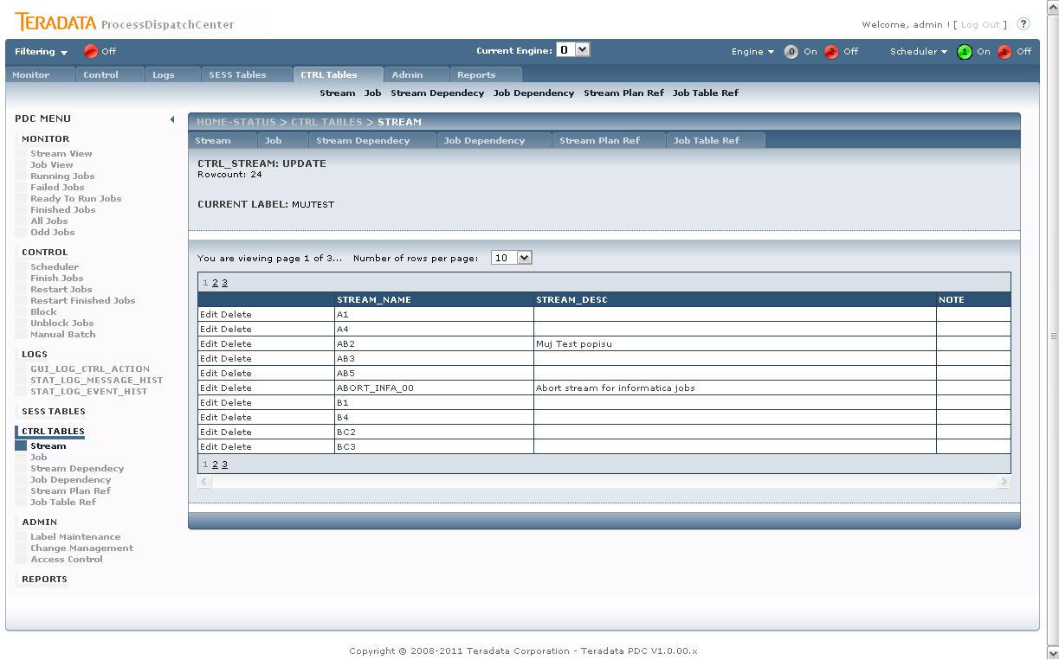
Figure 40 CTRL TABLES - Stream

The section lists all streams in PDC tables and allows the user to update (change/delete) streams. Implementation is done by simple GridView table with single Data source which provides with all SELECT, UPDATE and DELETE functionality.

<asp:SqlDataSource ID="SqlDataSource1" runat="server"

ConnectionString="<%$ ConnectionStrings:PDCOracleConnection.connectionString %>"
ProviderName="<%$ ConnectionStrings:PDCOracleConnection.ProviderName %>"
EnableViewState="False"

SelectCommand="PCKG_GUI.SP_GUI_VIEW_CTRL_STREAM"
SelectCommandType="StoredProcedure"
onselected="SqlDataSource_Selected" onselecting="SqlDataSource_Selecting"

UpdateCommandType="StoredProcedure"
UpdateCommand="PCKG_GUI.SP_GUI_UPDT_CTRL_STREAM"
onupdating="SqlDataSource_Updating" onupdated="SqlDataSource_Updated"

DeleteCommand="PCKG_GUI.SP_GUI_UPDT_CTRL_STREAM_DEL"
DeleteCommandType="StoredProcedure"
OnDeleting="SqlDataSource_Deleting" OnDeleted="SqlDataSource_Deleted"

>
<SelectParameters>
...

Job
Page: CTRL_JOB.aspx
Procedures:
- PCKG_GUI.SP_GUI_VIEW_CTRL_JOB
- PCKG_GUI.SP_GUI_UPDT_CTRL_JO
- PCKG_GUI.SP_GUI_UPDT_CTRL_JOB_DE

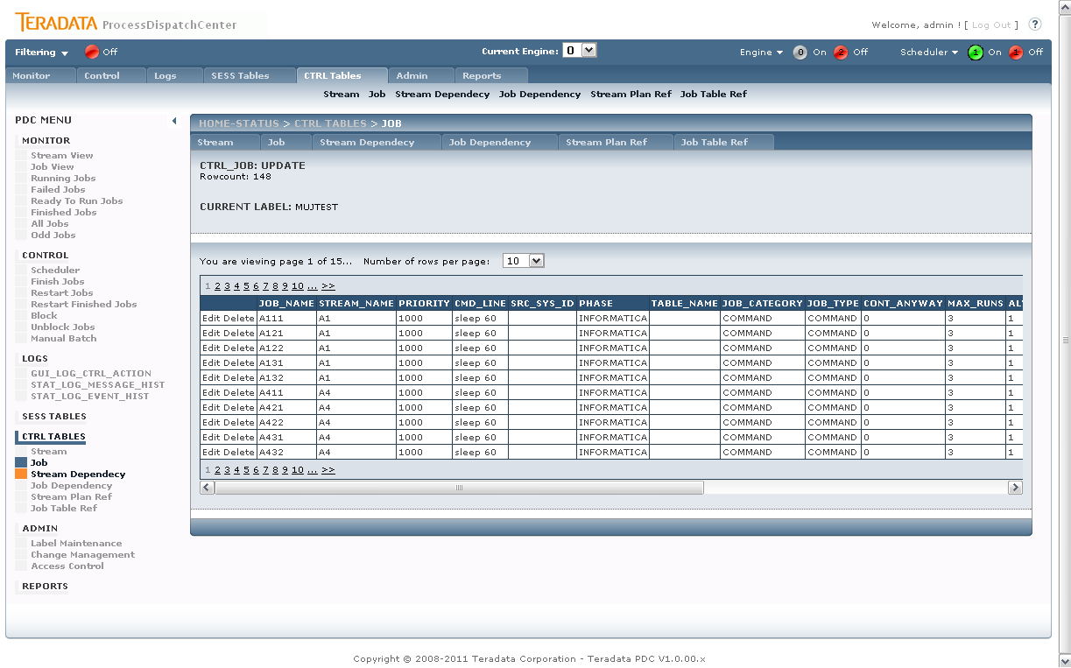
Figure 41 CTRL TABLES - Job

The section implementation is similar to section 3.6.1 Stream.

Stream Dependency
Page: CTRL_STREAM_DEPENDENCY.aspx
Procedures:
- PCKG_GUI.SP_GUI_VIEW_CTRL_STREAM
- PCKG_GUI.SP_GUI_VIEW_CTRL_STREAM_DEPAC
- PCKG_GUI.SP_GUI_VIEW_CTRL_STREAM_DEP
- PCKG_GUI.SP_GUI_UPDT_CTRL_STREAM_DEP
- PCKG_GUI.SP_GUI_DEL_CTRL_STREAM_DEP
This section provides user with ability to change Stream dependencies – create Stream tree structure. The user is given the complete list of Streams where he makes and selection of particular Stream.

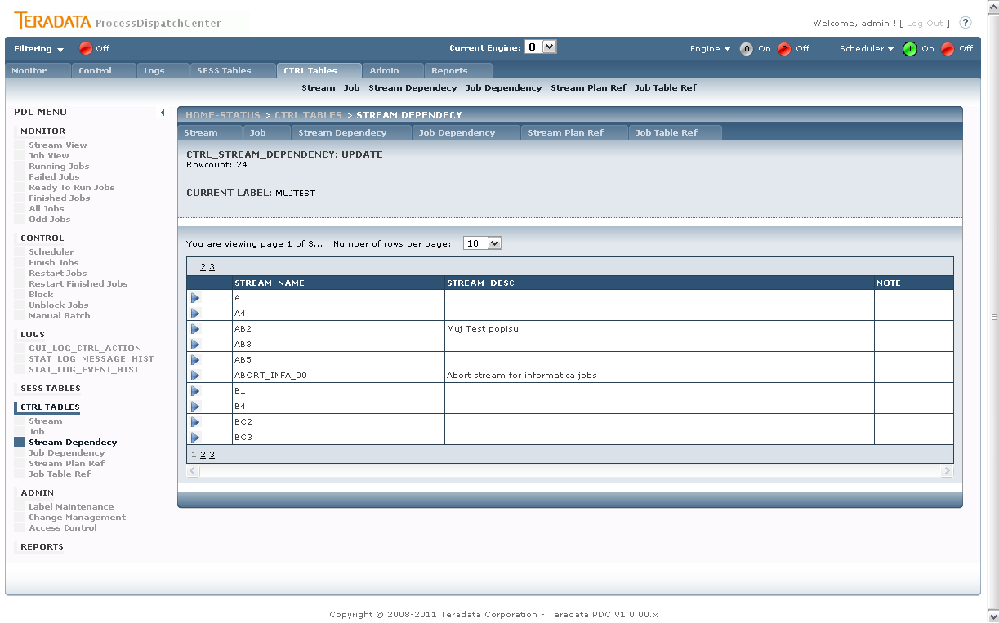
Figure 42 CTRL TABLES – Stream Dependency

The user selectd the particular Stream and additional paneals are revealed – panel with list of current parent Streams (PCKG_GUI.SP_GUI_VIEW_CTRL_STREAM_DEPAC) and the panel of possible Streams to bound in parent-child relation (PCKG_GUI.SP_GUI_VIEW_CTRL_STREAM_DEP) – both panels are marked with red in following picture.

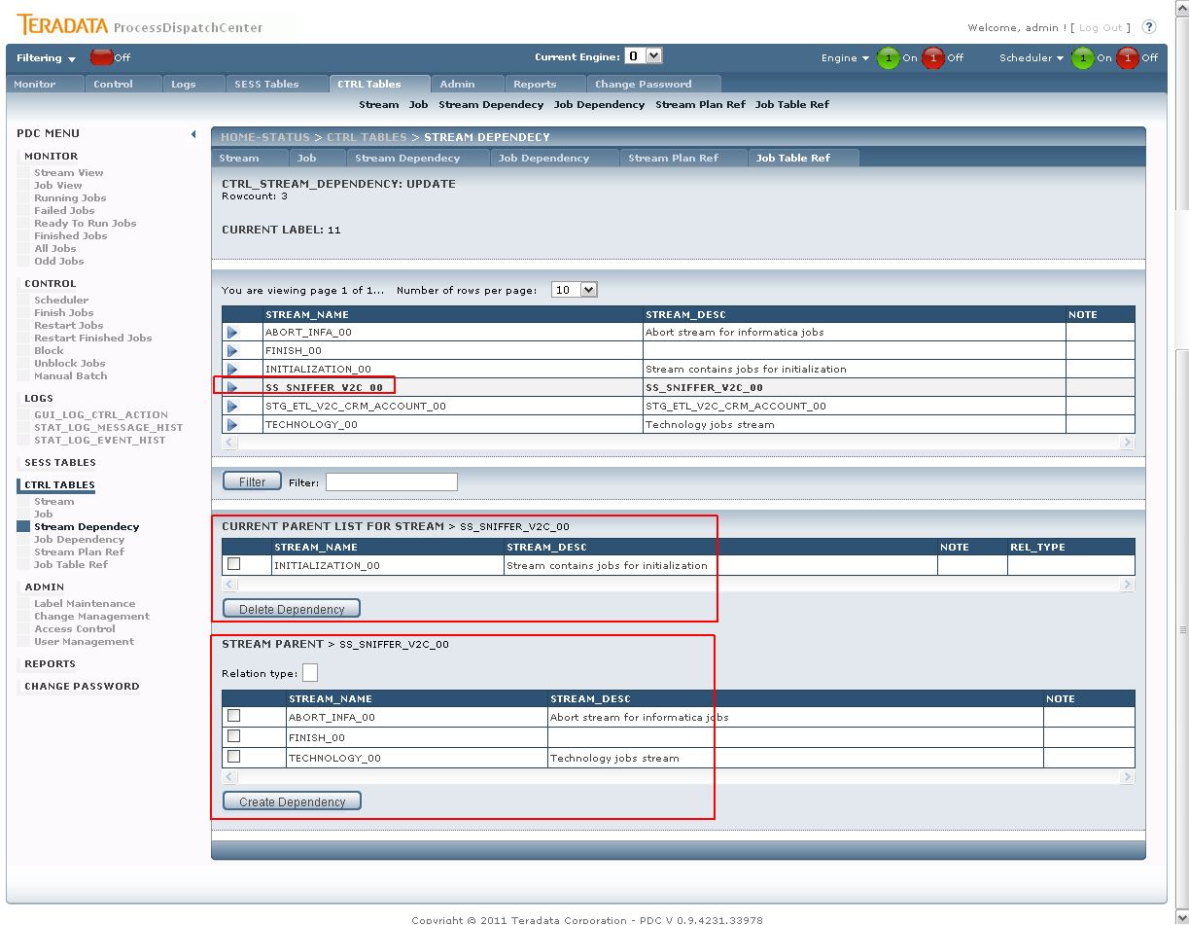
Figure 43 CTRL TABLES – Stream Dependency – particular stream selected

Additionally, user can delete existing relation by checking desired checkboxes in current parent list and hitting the “Delete Dependency” button which calls the PCKG_GUI.SP_GUI_DEL_CTRL_STREAM_DEP procedure.
When selecting the potential Stream parents, user can define a relation type (it is CHAR(1) value) – the value has no lookup table.

Job Dependency
Page: CTRL_JOB_DEPENDENCY.aspx
Procedures:
- PCKG_GUI.SP_GUI_VIEW_CTRL_JOB
- PCKG_GUI.SP_GUI_VIEW_CTRL_JOB_DEPAC
- PCKG_GUI.SP_GUI_VIEW_CTRL_JOB_DEP
- PCKG_GUI.SP_GUI_UPDT_CTRL_JOB_DEP
- PCKG_GUI.SP_GUI_DEL_CTRL_JOB_DEP

The section implementation is similar to section 3.6.3 Stream Dependency.

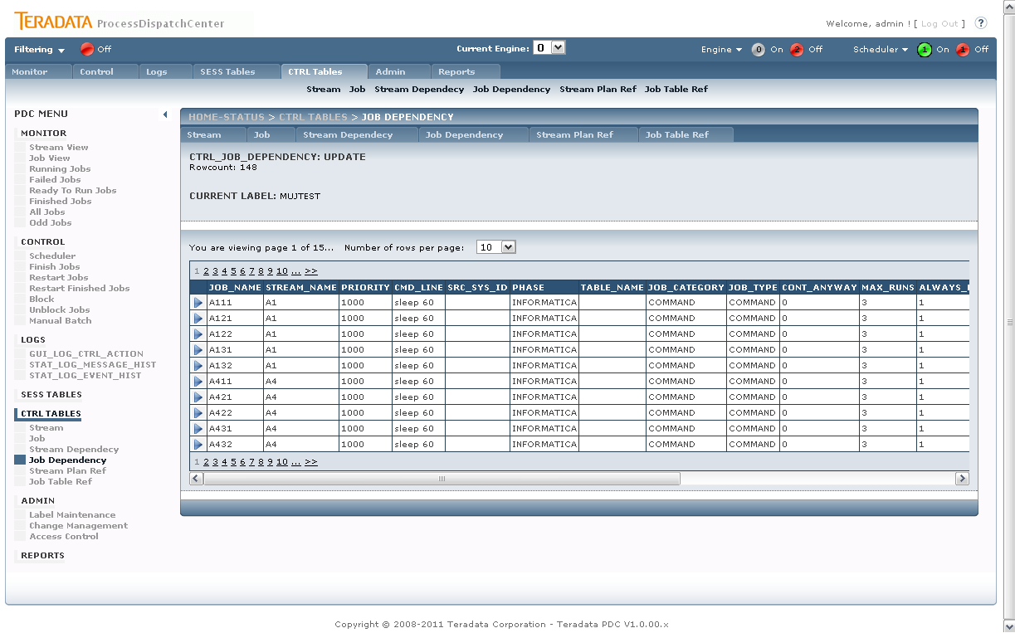
Figure 44 CTRL TABLES – Job Dependency

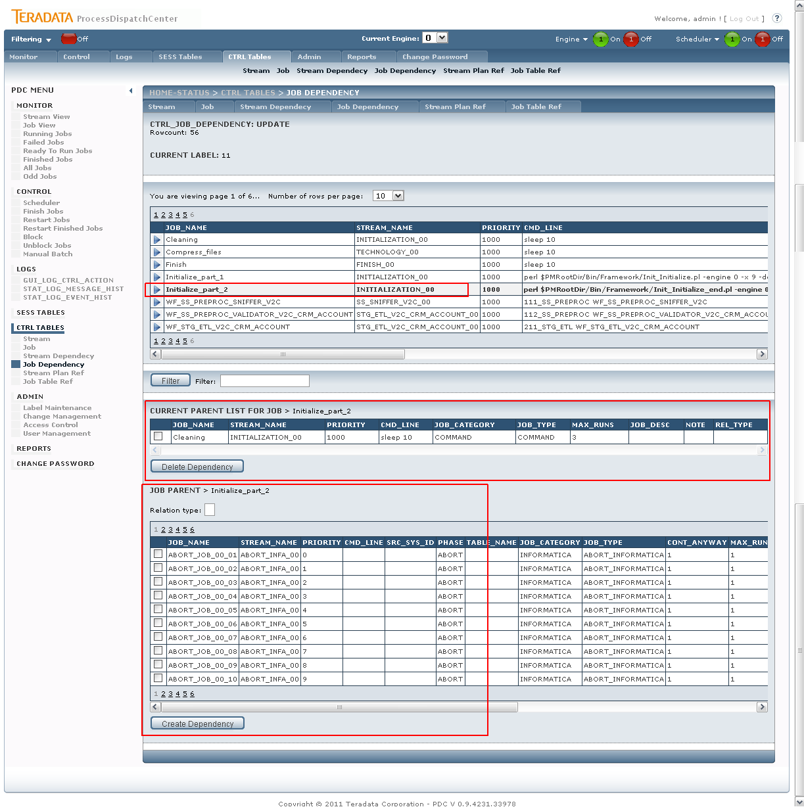
Figure 45 CTRL TABLES – Job Dependency – Job selected

Stream Plan Ref
Page: CTRL_STREAM_PLAN_REF.aspx
Procedures:
- PCKG_GUI.SP_GUI_VIEW_CTRL_STREAM
- PCKG_GUI.SP_GUI_VIEW_CTRL_STREAM_PLAN
- PCKG_GUI.SP_GUI_UPDT_CTRL_STREAM_PLAN

The section assigns selected plans to the selected Streams. The user have choose the desired Stream and then the Run Plan list with shows up. The currently assigned plans are marked as checked (see picture bellow).
The user can select more plans in the same time while the procedure (PCKG_GUI.SP_GUI_UPDT_CTRL_STREAM_PLAN) works in two steps:
- Delete all references (in relation table)
- Insert the relation table with new records (representing the current assignment).

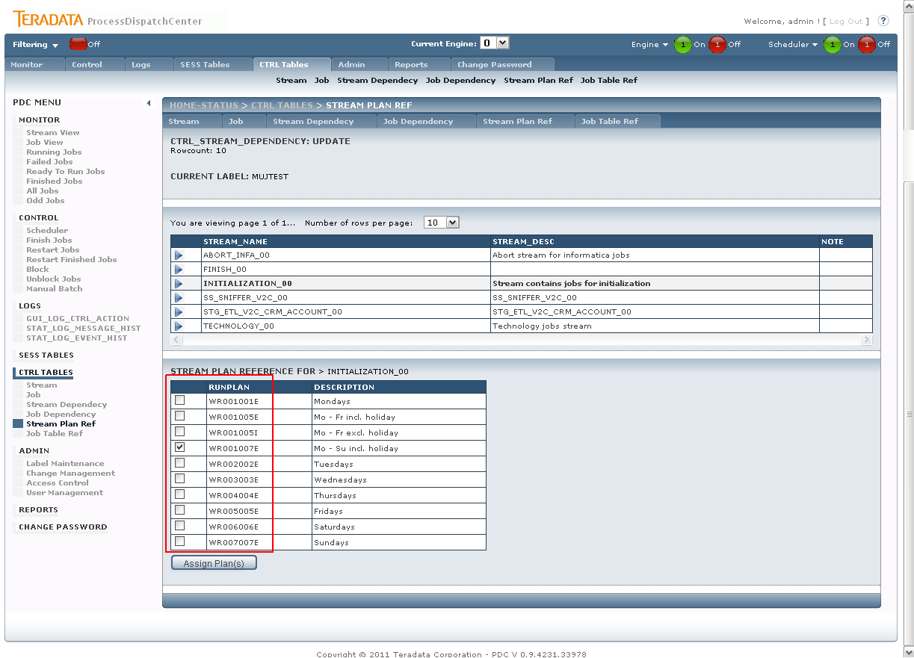
Figure 46 CTRL TABLES – Stream Plan Ref

Job Table Ref
Page: CTRL_JOB_TABLE_REF.aspx
Procedures:
- PCKG_GUI.SP_GUI_VIEW_CTRL_JOB
- PCKG_GUI.SP_GUI_VIEW_CTRL_JOB_TAB_REF
- PCKG_GUI.SP_GUI_UPDT_CTRL_JOB_TAB_REF
- PCKG_GUI.SP_GUI_DEL_CTRL_JOB_TAB_REF

In this section, the user assigns the jobs with tables in database and the type of lock (read/write). The user has to select a job in order to manage the plans assignment. Assigned plans can be deleted be ticking the checkbox and pressing the “Delete Reference” button which calls the PCKG_GUI.SP_GUI_DEL_CTRL_JOB_TAB_REF procedure.

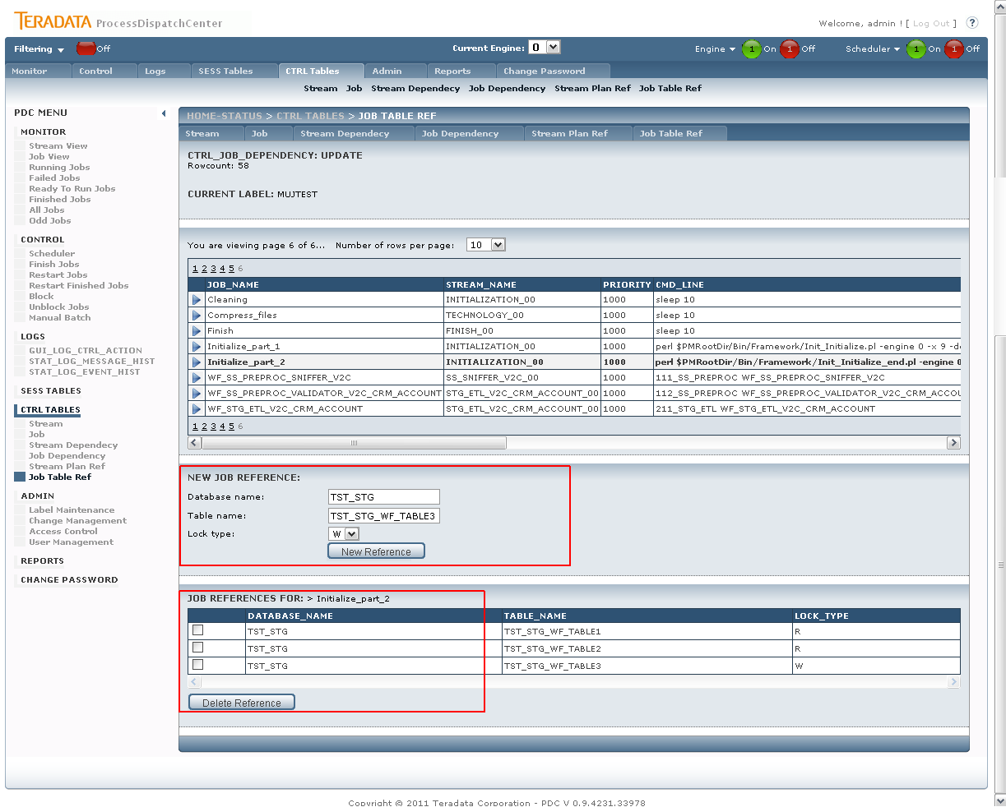
Figure 47 CTRL TABLES – Job Table ref

Admin

Label Maintenance
Page: AdminLabel.aspx
Procedures:
- PCKG_GUI.SP_GUI_VIEW_CHM
- PCKG_GUI.SP_GUI_UPDT_LABEL

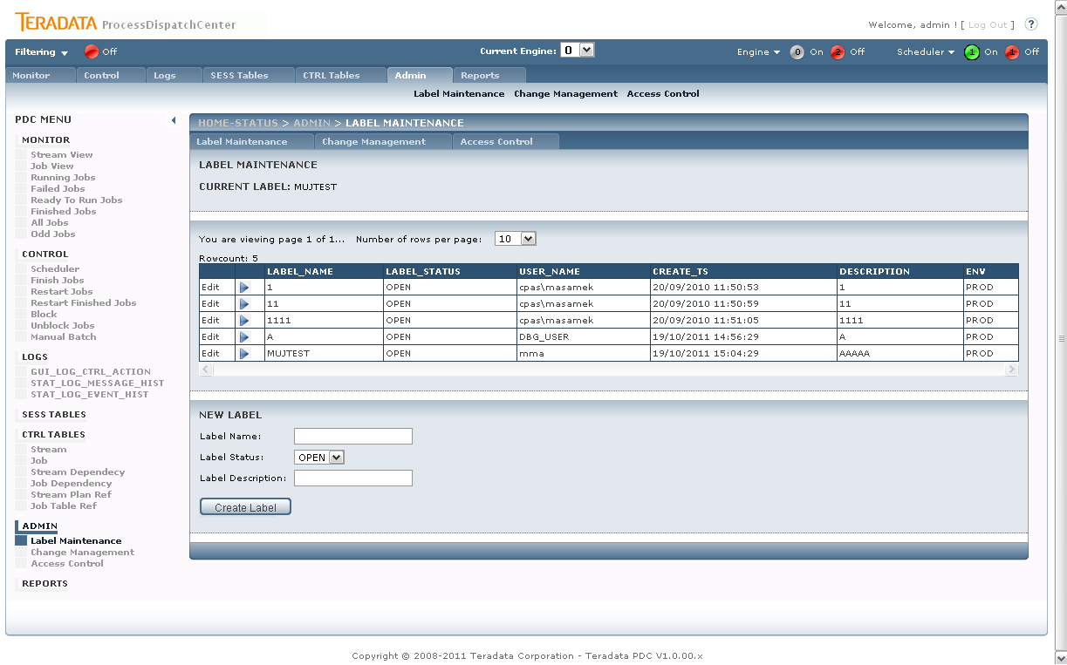
Figure 48 Label Maintenance
Label can be selected via the blue arrow – the label is stored in Session (see 3.1.2 Session object).
User can create a new Label (always in OPEN state). And the creation is done by LinkButton “Create Label” which calls the PCKG_GUI.SP_GUI_UPDT_LABEL procedure.

Change Management
Page: AdminChangeMangement.aspx
Procedures:
- PCKG_GUI.SP_GUI_UPDT_LABEL_BP

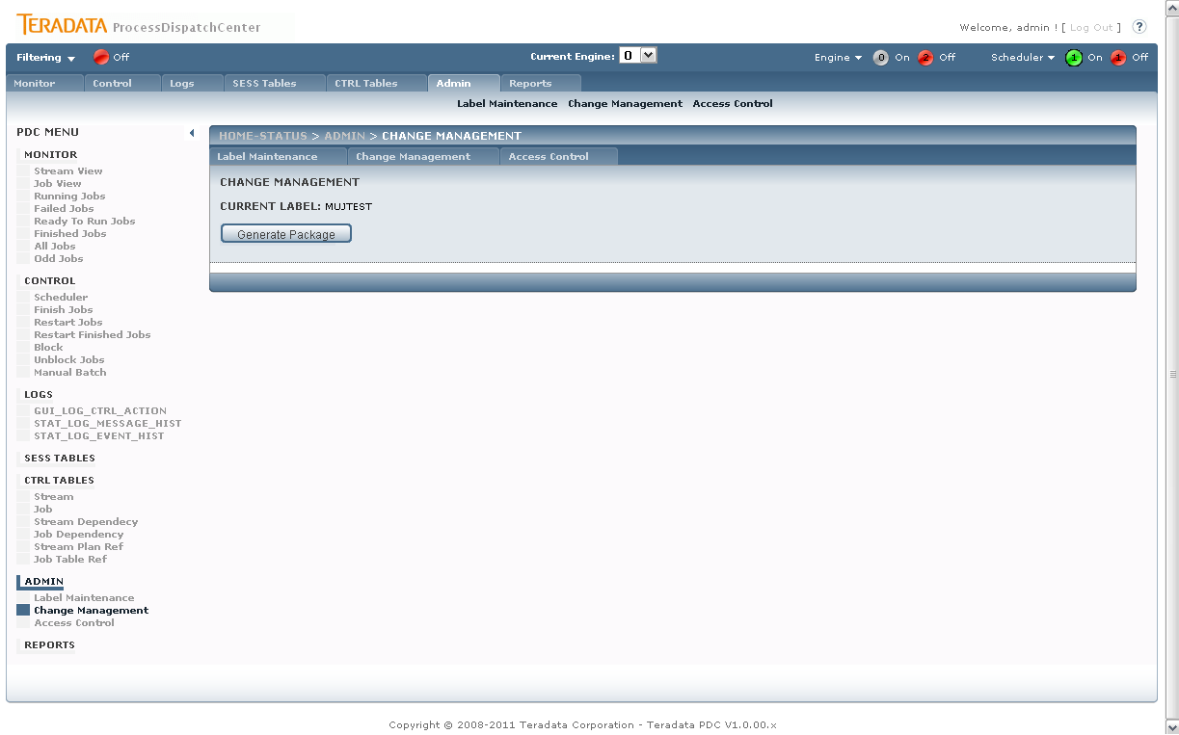
Figure 49 Admin Change management

This page provides user with ability to generate package according to selected Label (held in session – see previous section). The package generation is done by pressing “Generate Package” button, which calls the PCKG_GUI.SP_GUI_UPDT_LABEL_BP procedure.
The procedure output is parsed and put into a file which is sent to the user (download file).
Downloading file is done by modifying the page request:
try
{
HttpContext.Current.Response.ContentType = "application/octet-stream";
HttpContext.Current.Response.AddHeader("Content-Disposition", "attachment; filename=" + getPackageName());
HttpContext.Current.Response.Clear();
foreach (string line in packageOutput)
{
HttpContext.Current.Response.Write(line);
}
HttpContext.Current.Response.End();
}
catch (Exception ex)
{
((SiteMaster)Master).displayInfo("File generation failed with error:<br>" + ex.ToString());
}

The request is interrupted after the file download.

Access Control
This section is described in the chapter 3.1.8 Security.

User Management
This section is described in the chapter 3.1.8 Security.

Reports
Custom page – to be defined at customer site.

Change Password
This section is described in the chapter 3.1.8 Security.

Installation
This section describes the installation process of PDC GUI only. Installation of engine or other components is not part of this document.

Prerequisites

Hardware components
No special HW configuration is needed since the GUI is standard WEB application running on Microsoft IIS with limited access of user (only specified users are allowed to use the application).
Current specs:
Web server HP RAM DL360 G6 2x2.00QC - 8GB RAM, HP disc 2x146GB for DL and BL, 2 x HP HBA rack (DL) - 2x4GB FC Emulex, 2 x HP NIC rack (DL) - 4x1GB Eth

Software components
Web server: Microsoft Internet Information Services 6+
.NET Framework: 4.0
Operating system: Microsoft Windows XP/Vista/7, Microsoft Server 2003+
Browser: Microsoft Internet Explorer 7+, Mozilla Firefox 2+, Google Chrome
ODBC: Oracle Client ODBC (32b if environment needs 32bit)

Installation steps
Steps of installing/deploying the PDC GUI application:

  - Create Web application on IIS

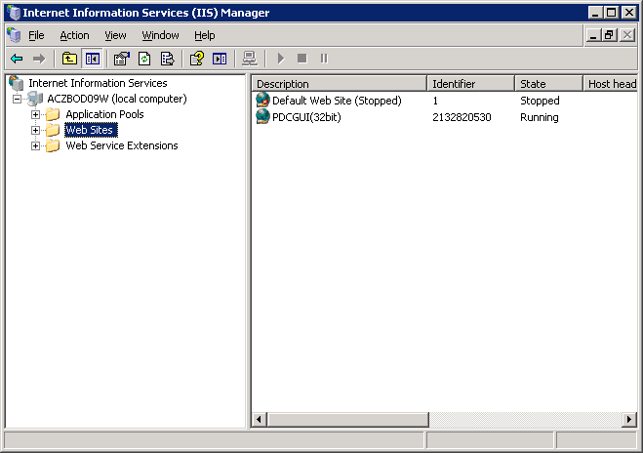

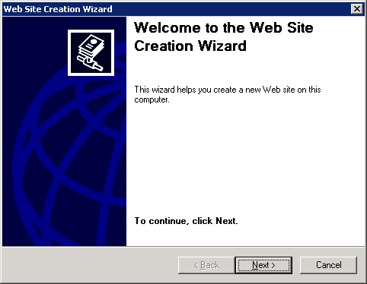

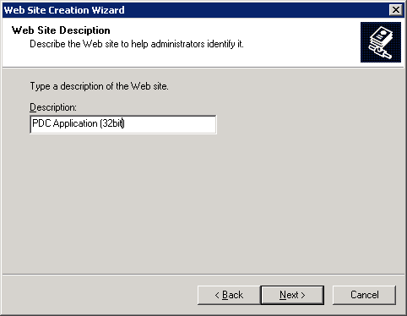

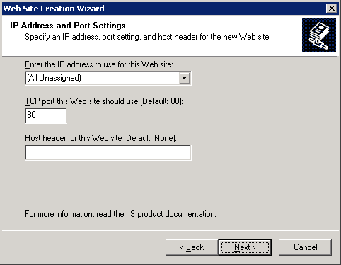

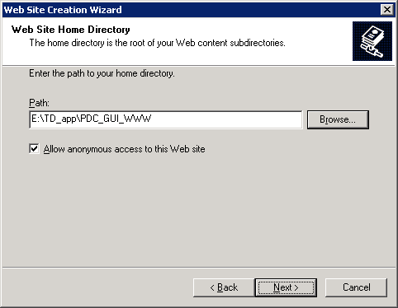

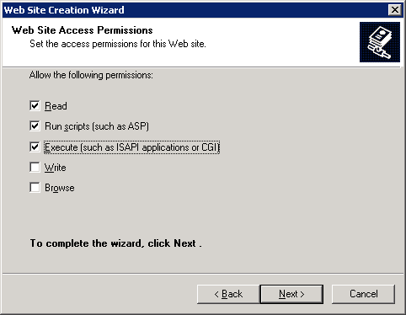

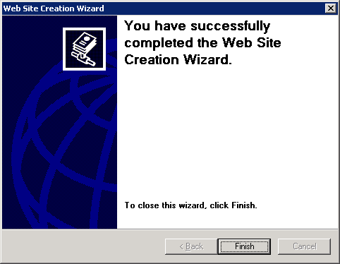

  - Copy contents of Application Package on IIS

Copy generated package files into the directory of application on IIS server.

  - Configure
    - Web.config

<?xml version="1.0"?>

<!--
For more information on how to configure your ASP.NET application, please visit
http://go.microsoft.com/fwlink/?LinkId=169433
-->

<configuration>

<connectionStrings>
<add name="ApplicationServices" connectionString="data source=.\SQLEXPRESS;Integrated Security=SSPI;AttachDBFilename=|DataDirectory|\aspnetdb.mdf;User Instance=true"
providerName="System.Data.SqlClient" />
<add name="PDCOracleConnection" connectionString="..." providerName="System.Data.OracleClient" />

</connectionStrings>
<appSettings>

<add key="DefaultPageItemCount" value="10" />
<add key="DefaultPageReloadTimer" value="20000" />
<add key="DefaultEngine" value="0" />
<add key="DisplayDebugSection" value="true"/>
<add key="DefaultOracleDateFormat" value="dd.MM.yyyy"/>
</appSettings>

<system.web>
<compilation debug="true" targetFramework="4.0" />
<pages renderAllHiddenFieldsAtTopOfForm="false" />

<customErrors mode="Off" defaultRedirect="~/errors/GeneralError.aspx">
</customErrors>

<authentication mode="Forms">
<forms loginUrl="~/Account/Login.aspx" timeout="2880" />
</authentication>

<authorization>
<deny users="?"/>
</authorization>

</system.web>

<location path="html">
<system.web>
<authorization>
<allow users="*"/>
</authorization>
</system.web>
</location>

<location path="errors">
<system.web>
<authorization>
<allow users="*"/>
</authorization>
</system.web>
</location>

<system.webServer>
<modules runAllManagedModulesForAllRequests="true"/>
</system.webServer>
</configuration>

    - Web Sites properties (on IIS)

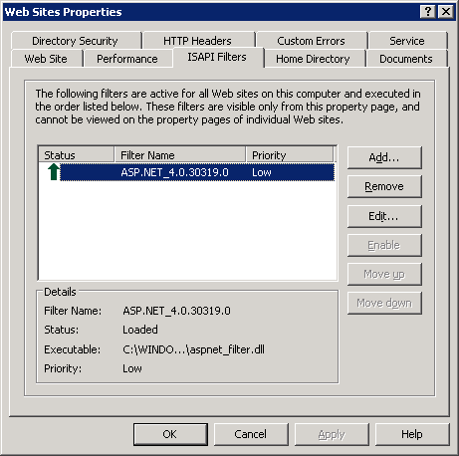

Troubleshooting

Version of OS vs ODBC
Version of OS and ODBC should be same – 32bit or 64bit both. In case of version of OS is 64bit and ODBC is 32bit, the IIS has to be reconfigured to run the PDC GUI application in 32b mode.
Follow the steps in:
http://www.microsoft.com/technet/prodtechnol/WindowsServer2003/Library/IIS/13f991a5-45eb-496c-8618-2179c3753bb0.mspx?mfr=true
http://www.microsoft.com/technet/prodtechnol/WindowsServer2003/Library/IIS/13f991a5-45eb-496c-8618-2179c3753bb0.mspx?mfr=true
and
according to article:
http://dillieodigital.wordpress.com/2010/10/07/windows-server-2003-64bit-iis-6-32bit-asp-net-4-framework-and-targeting/

- Open up the command prompt on the server and figure out how IIS is running by executing the following command:

cscript C:\inetpub\adminscripts\adsutil.vbs GET W3SVC/AppPools/Enable32BitAppOnWin64

- You should see ‘Enable32BitAppOnWin64 : (BOOLEAN) True.’

- 3 Is the server setup for 32-bit compatibility mode for legacy apps? If not execute the following command:

cscript C:\inetpub\adminscripts\adsutil.vbs SET W3SVC/AppPools/Enable32BitAppOnWin64 True

- Assuming it has been installed, make sure .Net 4 Framework is registered for ASP.Net by executing:

aspnet_regiis -i

- Find out what IIS extensions are enabled (0) and disabled (0) by executing teh following command:

C:\Windows\System32 “cscript iisext.vbs /ListFile

- If the .Net 4 Framework is disabled you will need to run the following command:

cscript iisext.vbs /EnFile C:\WINDOWS\Microsoft.NET\Framework\v4.0.30319\aspnet_isapi.dll

and verify that you now see a ’1′ in the status of the desired Framework.

- Now navigate to your Framework version folder and run the following command:

aspnet_regiis -lv

to list the status and installation path of all versions of ASP.NET that are installed on the computer. Notice the (Root) note that specifies this is the default Framework.

- Execute the following command:

aspnet_regiis -lk

to list the path and version of all IIS metabase keys where ASP.NET is mapped.

- Note in the attached image that the desired application DSMapApp is still targeting the 2.0 framework EVEN THOUGH running aspnet_regiis -i is supposed to switch all apps to the specified Framework.

- To switch a particular application’s targeted Framework we’ll need the -s switch to Update scriptmaps and application-pool assignments for the specified application and for all sub-applications.:

aspnet_regiis -s W3SVC/1/Root/[AppName]

…and that should do it. The following screen shot below traces the commands executed.

Future requests
N/A

